

**DAYANANDA SAGAR COLLEGE OF ENGINEERING**

Accredited by National Assessment & Accreditation Council (NAAC) with ’A’ Grade

*(AICTE Approved, an Autonomous Institute Affiliated to VTU, Belagavi)*

Shavige Malleshwara Hills, Kumaraswamy Layout, Bengaluru-560111

**DEPARTMENT OF MECHANICAL ENGINEERING**

**(Accredited by NBA)**

**A Project Report on**

**“Optimization and Characterization of Fused Deposition Modelling (FDM) Parameters for Enhanced Mechanical Properties in 3D Printed material for Biomedical application”**

*Submitted in partial fulfilment for the award of degree of*

**BACHELOR OF ENGINEERING**

In

**MECHANICAL ENGINEERING**

*2023-2024*

*Submitted by*

|  |  |
| --- | --- |
| **1DS20ME044** | **Mallanna** |
| **1DS20ME420** | **Naveenakumar Annennanavar** |
| **1DS21ME455** | **Rakesha K P** |
| **1DS21ME478** | **Sudarshan N D** |

*Under the guidance of*

**Dr. VIVEK BHANDARKAR VN**

Assistant Professor

Department of Mechanical Engineering,

Dayananda Sagar College of Engineering

Shavige Malleshwara Hills, Kumaraswamy Layout, Bengaluru-560078



**DAYANANDA SAGAR COLLEGE OF ENGINEERING**

Accredited by National Assessment & Accreditation Council (NAAC) with ’A’ Grade

*(AICTE Approved, an Autonomous Institute Affiliated to VTU, Belagavi)*

Shavige Malleshwara Hills, Kumaraswamy Layout, Bengaluru-560078

**DEPARTMENT OF MECHANICAL ENGINEERING**

**(Accredited by NBA)**

***Certificate***

Certified that the project report entitled **‘Optimization and Characterization of Fused Deposition Modelling (FDM) Parameters for Enhanced Mechanical Properties in 3D Printed material for Biomedical application’** is a Bonafide work carried out by **Mallanna**, bearing USN**: 1DS20ME044**, **Naveenakumar Annennanavar**, bearing USN**: 1DS20ME420**, **Rakesha K P**, bearing USN**: 1DS21ME455**, **Sudarshan N D**, bearing USN**: 1DS21ME478**, under the guidance of **Dr. Vivek Bhandarkar V** **N** , **Assistant Professor** , Department of Mechanical Engineering, Dayananda Sagar College of Engineering, Bengaluru, in partial fulfilment for the award of Bachelor of Engineering in Mechanical Engineering of the Visvesvaraya Technological University, Belagavi.

Dr. Vivek Bhandarkar V N

Assistant Professor

Department of Mechanical Engineering

Dayananda Sagar College of Engineering.

Bengaluru

SL.NO. Name of the Examiner Signature with DateDr Aruna Devi

Assistant Professor, Dept. of Mech. Engg

Dayananda Sagar College of Engineering.

Bengaluru

SL.NO. Name of the Examiner Signature with Date

SL.NO. Name of the Examiner Signature with DateDr Aruna Devi

Assistant Professor, Dept. of Mech. Engg

Dayananda Sagar College of Engineering.

Bengaluru

SL.NO. Name of the Examiner Signature with DateDr Aruna Devi

Assistant Professor, Dept. of Mech. Engg

Dayananda Sagar College of Engineering.

Bengaluru

SL.NO. Name of the Examiner Signature with Date

SL.NO. Name of the Examiner Signature with Date

SL.NO. Name of the Examiner Signature with Date

SL.NO. Name of the Examiner Signature with DateDr Aruna Devi

Assistant Professor, Dept. of Mech. Engg

Dayananda Sagar College of Engineering.

Bengaluru

SL.NO. Name of the Examiner Signature with DateDr Aruna Devi

Assistant Professor, Dept. of Mech. Engg

Dayananda Sagar College of Engineering.

Bengaluru

SL.NO. Name of the Examiner Signature with Date

SL.NO. Name of the Examiner Signature with DateDr Aruna Devi

Assistant Professor, Dept. of Mech. Engg

Dayananda Sagar College of Engineering.

Bengaluru

SL.NO. Name of the Examiner Signature with DateDr Aruna Devi

Assistant Professor, Dept. of Mech. Engg

Dayananda Sagar College of Engineering.

Bengaluru

SL.NO. Name of the Examiner Signature with Date

SL.NO. Name of the Examiner Signature with Date

SL.NO. Name of the Examiner Signature with Date

SL.NO. Name of the Examiner Signature with Date

SL.NO. Name of the Examiner Signature with Date

SL.NO. Name of the Examiner Signature with Date

SL.NO. Name of the Examiner Signature with Date

SL.NO. Name of the Examiner Signature with DateDr Aruna Devi

Assistant Professor, Dept. of Mech. Engg

Dayananda Sagar College of Engineering.

Bengaluru

SL.NO. Name of the Examiner Signature with DateDr Aruna Devi

Assistant Professor, Dept. of Mech. Engg

Dayananda Sagar College of Engineering.

Bengaluru

SL.NO. Name of the Examiner Signature with Date

SL.NO. Name of the Examiner Signature with DateDr Aruna Devi

Assistant Professor, Dept. of Mech. Engg

Dayananda Sagar College of Engineering.

Bengaluru

SL.NO. Name of the Examiner Signature with DateDr Aruna Devi

Assistant Professor, Dept. of Mech. Engg

Dayananda Sagar College of Engineering.

Bengaluru

SL.NO. Name of the Examiner Signature with Date

SL.NO. Name of the Examiner Signature with Date

SL.NO. Name of the Examiner Signature with Date

SL.NO. Name of the Examiner Signature with DateDr Aruna Devi

Assistant Professor, Dept. of Mech. Engg

Dayananda Sagar College of Engineering.

Bengaluru

SL.NO. Name of the Examiner Signature with DateDr Aruna Devi

Assistant Professor, Dept. of Mech. Engg

Dayananda Sagar College of Engineering.

Bengaluru

SL.NO. Name of the Examiner Signature with Date

SL.NO. Name of the Examiner Signature with DateDr Aruna Devi

Assistant Professor, Dept. of Mech. Engg

Dayananda Sagar College of Engineering.

Bengaluru

SL.NO. Name of the Examiner Signature with DateDr Aruna Devi

Assistant Professor, Dept. of Mech. Engg

Dayananda Sagar College of Engineering.

Bengaluru

Dr. R. Keshavamurthy

Professor & Head

Department of Mechanical Engineering

Dayananda Sagar College of Engineering.

Bengaluru

Dr Aruna DeviDr. R. Keshavamurthy

Professor & Head, Dept. of Mech. Engg

Dayananda Sagar College of Engineering.

Bengaluru

Dr Aruna Devi

Assistant Professor, Dept. of Mech. Engg

Dayananda Sagar College of Engineering.

Bengaluru

SL.NO. Name of the Examiner Signature with DateDr Aruna DeviDr. R. Keshavamurthy

Professor & Head, Dept. of Mech. Engg

Dayananda Sagar College of Engineering.

Bengaluru

Dr Aruna DeviDr. R. Keshavamurthy

Professor & Head, Dept. of Mech. Engg

Dayananda Sagar College of Engineering.

Bengaluru

Dr Aruna Devi

Assistant Professor, Dept. of Mech. Engg

Dayananda Sagar College of Engineering.

Bengaluru

SL.NO. Name of the Examiner Signature with DateDr Aruna Devi

Assistant Professor, Dept. of Mech. Engg

Dayananda Sagar College of Engineering.

Bengaluru

SL.NO. Name of the Examiner Signature with Date

SL.NO. Name of the Examiner Signature with DateDr Aruna Devi

Assistant Professor, Dept. of Mech. Engg

Dayananda Sagar College of Engineering.

Bengaluru

SL.NO. Name of the Examiner Signature with DateDr Aruna DeviDr. R. Keshavamurthy

Professor & Head, Dept. of Mech. Engg

Dayananda Sagar College of Engineering.

Bengaluru

Dr Aruna DeviDr. R. Keshavamurthy

Professor & Head, Dept. of Mech. Engg

Dayananda Sagar College of Engineering.

Bengaluru

Dr Aruna Devi

Assistant Professor, Dept. of Mech. Engg

Dayananda Sagar College of Engineering.

Bengaluru

SL.NO. Name of the Examiner Signature with DateDr Aruna DeviDr. R. Keshavamurthy

Professor & Head, Dept. of Mech. Engg

Dayananda Sagar College of Engineering.

Bengaluru

Dr Aruna DeviDr. R. Keshavamurthy

Professor & Head, Dept. of Mech. Engg

Dayananda Sagar College of Engineering.

Bengaluru

Dr Aruna Devi

Assistant Professor, Dept. of Mech. Engg

Dayananda Sagar College of Engineering.

Bengaluru

SL.NO. Name of the Examiner Signature with DateDr Aruna Devi

Assistant Professor, Dept. of Mech. Engg

Dayananda Sagar College of Engineering.

Bengaluru

SL.NO. Name of the Examiner Signature with Date

SL.NO. Name of the Examiner Signature with DateDr Aruna Devi

Assistant Professor, Dept. of Mech. Engg

Dayananda Sagar College of Engineering.

Bengaluru

SL.NO. Name of the Examiner Signature with DateDr Aruna Devi

Assistant Professor, Dept. of Mech. Engg

Dayananda Sagar College of Engineering.

Bengaluru

SL.NO. Name of the Examiner Signature with Date

SL.NO. Name of the Examiner Signature with Date

SL.NO. Name of the Examiner Signature with Date

SL.NO. Name of the Examiner Signature with DateDr Aruna Devi

Assistant Professor, Dept. of Mech. Engg

Dayananda Sagar College of Engineering.

Bengaluru

SL.NO. Name of the Examiner Signature with DateDr Aruna Devi

Assistant Professor, Dept. of Mech. Engg

Dayananda Sagar College of Engineering.

Bengaluru

SL.NO. Name of the Examiner Signature with Date

SL.NO. Name of the Examiner Signature with DateDr Aruna Devi

Assistant Professor, Dept. of Mech. Engg

Dayananda Sagar College of Engineering.

Bengaluru

SL.NO. Name of the Examiner Signature with DateDr Aruna DeviDr. R. Keshavamurthy

Professor & Head, Dept. of Mech. Engg

Dayananda Sagar College of Engineering.

Bengaluru

Dr Aruna DeviDr. R. Keshavamurthy

Professor & Head, Dept. of Mech. Engg

Dayananda Sagar College of Engineering.

Bengaluru

Dr Aruna Devi

Assistant Professor, Dept. of Mech. Engg

Dayananda Sagar College of Engineering.

Bengaluru

SL.NO. Name of the Examiner Signature with DateDr Aruna DeviDr. R. Keshavamurthy

Professor & Head, Dept. of Mech. Engg

Dayananda Sagar College of Engineering.

Bengaluru

Dr Aruna DeviDr. R. Keshavamurthy

Professor & Head, Dept. of Mech. Engg

Dayananda Sagar College of Engineering.

Bengaluru

Dr Aruna Devi

Assistant Professor, Dept. of Mech. Engg

Dayananda Sagar College of Engineering.

Bengaluru

SL.NO. Name of the Examiner Signature with DateDr Aruna Devi

Assistant Professor, Dept. of Mech. Engg

Dayananda Sagar College of Engineering.

Bengaluru

SL.NO. Name of the Examiner Signature with Date

SL.NO. Name of the Examiner Signature with DateDr Aruna Devi

Assistant Professor, Dept. of Mech. Engg

Dayananda Sagar College of Engineering.

Bengaluru

SL.NO. Name of the Examiner Signature with DateDr Aruna DeviDr. R. Keshavamurthy

Professor & Head, Dept. of Mech. Engg

Dayananda Sagar College of Engineering.

Bengaluru

Dr Aruna DeviDr. R. Keshavamurthy

Professor & Head, Dept. of Mech. Engg

Dayananda Sagar College of Engineering.

Bengaluru

Dr Aruna Devi

Assistant Professor, Dept. of Mech. Engg

Dayananda Sagar College of Engineering.

Bengaluru

SL.NO. Name of the Examiner Signature with DateDr Aruna DeviDr. R. Keshavamurthy

Professor & Head, Dept. of Mech. Engg

Dayananda Sagar College of Engineering.

Bengaluru

Dr Aruna DeviDr. R. Keshavamurthy

Professor & Head, Dept. of Mech. Engg

Dayananda Sagar College of Engineering.

Bengaluru

Dr Arunadevi M

Assistant Professor, Dept. of Mech. Engg

Dayananda Sagar College of Engineering.

Bengaluru

SL.NO. Name of the Examiner Signature with DateDr Aruna Devi

Assistant Professor, Dept. of Mech. Engg

Dayananda Sagar College of Engineering.

Bengaluru

SL.NO. Name of the Examiner Signature with Date

SL.NO. Name of the Examiner Signature with DateDr Aruna Devi

Assistant Professor, Dept. of Mech. Engg

Dayananda Sagar College of Engineering.

Bengaluru

SL.NO. Name of the Examiner Signature with DateDr Aruna Devi

Assistant Professor, Dept. of Mech. Engg

Dayananda Sagar College of Engineering.

Bengaluru

SL.NO. Name of the Examiner Signature with Date

SL.NO. Name of the Examiner Signature with Date

SL.NO. Name of the Examiner Signature with Date

SL.NO. Name of the Examiner Signature with DateDr Aruna Devi

Assistant Professor, Dept. of Mech. Engg

Dayananda Sagar College of Engineering.

Bengaluru

SL.NO. Name of the Examiner Signature with DateDr Aruna Devi

Assistant Professor, Dept. of Mech. Engg

Dayananda Sagar College of Engineering.

Bengaluru

SL.NO. Name of the Examiner Signature with Date

SL.NO. Name of the Examiner Signature with DateDr Aruna Devi

Assistant Professor, Dept. of Mech. Engg

Dayananda Sagar College of Engineering.

Bengaluru

SL.NO. Name of the Examiner Signature with DateDr Aruna Devi

Assistant Professor, Dept. of Mech. Engg

Dayananda Sagar College of Engineering.

Bengaluru

SL.NO. Name of the Examiner Signature with Date

SL.NO. Name of the Examiner Signature with Date

SL.NO. Name of the Examiner Signature with Date

SL.NO. Name of the Examiner Signature with Date

SL.NO. Name of the Examiner Signature with Date

SL.NO. Name of the Examiner Signature with Date

SL.NO. Name of the Examiner Signature with Date

SL.NO. Name of the Examiner Signature with DateDr Aruna Devi

Assistant Professor, Dept. of Mech. Engg

Dayananda Sagar College of Engineering.

Bengaluru

SL.NO. Name of the Examiner Signature with DateDr Aruna Devi

Assistant Professor, Dept. of Mech. Engg

Dayananda Sagar College of Engineering.

Bengaluru

SL.NO. Name of the Examiner Signature with Date

SL.NO. Name of the Examiner Signature with DateDr Aruna Devi

Assistant Professor, Dept. of Mech. Engg

Dayananda Sagar College of Engineering.

Bengaluru

SL.NO. Name of the Examiner Signature with DateDr Aruna Devi

Assistant Professor, Dept. of Mech. Engg

Dayananda Sagar College of Engineering.

Bengaluru

SL.NO. Name of the Examiner Signature with Date

SL.NO. Name of the Examiner Signature with Date

SL.NO. Name of the Examiner Signature with Date

SL.NO. Name of the Examiner Signature with DateDr Aruna Devi

Assistant Professor, Dept. of Mech. Engg

Dayananda Sagar College of Engineering.

Bengaluru

SL.NO. Name of the Examiner Signature with DateDr Aruna Devi

Assistant Professor, Dept. of Mech. Engg

Dayananda Sagar College of Engineering.

Bengaluru

SL.NO. Name of the Examiner Signature with Date

SL.NO. Name of the Examiner Signature with DateDr Aruna Devi

Assistant Professor, Dept. of Mech. Engg

Dayananda Sagar College of Engineering.

Bengaluru

SL.NO. Name of the Examiner Signature with DateDr Aruna DeviDr. R. Keshavamurthy

Professor & Head, Dept. of Mech. Engg

Dayananda Sagar College of Engineering.

Bengaluru

Dr Aruna DeviDr. R. Keshavamurthy

Professor & Head, Dept. of Mech. Engg

Dayananda Sagar College of Engineering.

Bengaluru

Dr Aruna Devi

Assistant Professor, Dept. of Mech. Engg

Dayananda Sagar College of Engineering.

Bengaluru

SL.NO. Name of the Examiner Signature with DateDr Aruna DeviDr. R. Keshavamurthy

Professor & Head, Dept. of Mech. Engg

Dayananda Sagar College of Engineering.

Bengaluru

Dr Aruna DeviDr. R. Keshavamurthy

Professor & Head, Dept. of Mech. Engg

Dayananda Sagar College of Engineering.

Bengaluru

Dr Aruna Devi

Assistant Professor, Dept. of Mech. Engg

Dayananda Sagar College of Engineering.

Bengaluru

SL.NO. Name of the Examiner Signature with DateDr Aruna Devi

Assistant Professor, Dept. of Mech. Engg

Dayananda Sagar College of Engineering.

Bengaluru

SL.NO. Name of the Examiner Signature with Date

SL.NO. Name of the Examiner Signature with DateDr Aruna Devi

Assistant Professor, Dept. of Mech. Engg

Dayananda Sagar College of Engineering.

Bengaluru

SL.NO. Name of the Examiner Signature with DateDr Aruna DeviDr. R. Keshavamurthy

Professor & Head, Dept. of Mech. Engg

Dayananda Sagar College of Engineering.

Bengaluru

Dr Aruna DeviDr. R. Keshavamurthy

Professor & Head, Dept. of Mech. Engg

Dayananda Sagar College of Engineering.

Bengaluru

Dr Aruna Devi

Assistant Professor, Dept. of Mech. Engg

Dayananda Sagar College of Engineering.

Bengaluru

SL.NO. Name of the Examiner Signature with DateDr Aruna DeviDr. R. Keshavamurthy

Professor & Head, Dept. of Mech. Engg

Dayananda Sagar College of Engineering.

Bengaluru

Dr Aruna DeviDr. R. Keshavamurthy

Professor & Head, Dept. of Mech. Engg

Dayananda Sagar College of Engineering.

Bengaluru

Dr Aruna Devi

Assistant Professor, Dept. of Mech. Engg

Dayananda Sagar College of Engineering.

Bengaluru

SL.NO. Name of the Examiner Signature with DateDr Aruna Devi

Assistant Professor, Dept. of Mech. Engg

Dayananda Sagar College of Engineering.

Bengaluru

SL.NO. Name of the Examiner Signature with Date

SL.NO. Name of the Examiner Signature with DateDr Aruna Devi

Assistant Professor, Dept. of Mech. Engg

Dayananda Sagar College of Engineering.

Bengaluru

SL.NO. Name of the Examiner Signature with DateDr Aruna Devi

Assistant Professor, Dept. of Mech. Engg

Dayananda Sagar College of Engineering.

Bengaluru

SL.NO. Name of the Examiner Signature with Date

SL.NO. Name of the Examiner Signature with Date

SL.NO. Name of the Examiner Signature with Date

SL.NO. Name of the Examiner Signature with DateDr Aruna Devi

Assistant Professor, Dept. of Mech. Engg

Dayananda Sagar College of Engineering.

Bengaluru

SL.NO. Name of the Examiner Signature with DateDr Aruna Devi

Assistant Professor, Dept. of Mech. Engg

Dayananda Sagar College of Engineering.

Bengaluru

SL.NO. Name of the Examiner Signature with Date

SL.NO. Name of the Examiner Signature with DateDr Aruna Devi

Assistant Professor, Dept. of Mech. Engg

Dayananda Sagar College of Engineering.

Bengaluru

SL.NO. Name of the Examiner Signature with DateDr Aruna DeviDr. R. Keshavamurthy

Professor & Head, Dept. of Mech. Engg

Dayananda Sagar College of Engineering.

Bengaluru

Dr Aruna DeviDr. R. Keshavamurthy

Professor & Head, Dept. of Mech. Engg

Dayananda Sagar College of Engineering.

Bengaluru

Dr Aruna Devi

Assistant Professor, Dept. of Mech. Engg

Dayananda Sagar College of Engineering.

Bengaluru

SL.NO. Name of the Examiner Signature with DateDr Aruna DeviDr. R. Keshavamurthy

Professor & Head, Dept. of Mech. Engg

Dayananda Sagar College of Engineering.

Bengaluru

Dr Aruna DeviDr. R. Keshavamurthy

Professor & Head, Dept. of Mech. Engg

Dayananda Sagar College of Engineering.

Bengaluru

Dr Aruna Devi

Assistant Professor, Dept. of Mech. Engg

Dayananda Sagar College of Engineering.

Bengaluru

SL.NO. Name of the Examiner Signature with DateDr Aruna Devi

Assistant Professor, Dept. of Mech. Engg

Dayananda Sagar College of Engineering.

Bengaluru

SL.NO. Name of the Examiner Signature with Date

SL.NO. Name of the Examiner Signature with DateDr Aruna Devi

Assistant Professor, Dept. of Mech. Engg

Dayananda Sagar College of Engineering.

Bengaluru

SL.NO. Name of the Examiner Signature with DateDr Aruna DeviDr. R. Keshavamurthy

Professor & Head, Dept. of Mech. Engg

Dayananda Sagar College of Engineering.

Bengaluru

Dr Aruna DeviDr. R. Keshavamurthy

Professor & Head, Dept. of Mech. Engg

Dayananda Sagar College of Engineering.

Bengaluru

Dr Aruna Devi

Assistant Professor, Dept. of Mech. Engg

Dayananda Sagar College of Engineering.

Bengaluru

SL.NO. Name of the Examiner Signature with DateDr Aruna DeviDr. R. Keshavamurthy

Professor & Head, Dept. of Mech. Engg

Dayananda Sagar College of Engineering.

Bengaluru

Dr Aruna DeviDr. R. Keshavamurthy

Professor & Head, Dept. of Mech. Engg

Dayananda Sagar College of Engineering.

Bengaluru

Dr. B G Prasad

Principal

Dayananda Sagar College of Engineering.

Bengaluru

Dr. R. KeshavamurthyDr. C. P. S. Prakash

Principal

Dayananda Sagar College of Engineering.

Bengaluru

Dr. R. Keshavamurthy

Professor & Head, Dept. of Mech. Engg

Dayananda Sagar College of Engineering.

Bengaluru

Dr Aruna DeviDr. R. KeshavamurthyDr. C. P. S. Prakash

Principal

Dayananda Sagar College of Engineering.

Bengaluru

Dr. R. KeshavamurthyDr. C. P. S. Prakash

Principal

Dayananda Sagar College of Engineering.

Bengaluru

Dr. R. Keshavamurthy

Professor & Head, Dept. of Mech. Engg

Dayananda Sagar College of Engineering.

Bengaluru

Dr Aruna DeviDr. R. Keshavamurthy

Professor & Head, Dept. of Mech. Engg

Dayananda Sagar College of Engineering.

Bengaluru

Dr Aruna Devi

Assistant Professor, Dept. of Mech. Engg

Dayananda Sagar College of Engineering.

Bengaluru

SL.NO. Name of the Examiner Signature with DateDr Aruna DeviDr. R. Keshavamurthy

Professor & Head, Dept. of Mech. Engg

Dayananda Sagar College of Engineering.

Bengaluru

Dr Aruna DeviDr. R. KeshavamurthyDr. C. P. S. Prakash

Principal

Dayananda Sagar College of Engineering.

Bengaluru

Dr. R. KeshavamurthyDr. C. P. S. Prakash

Principal

Dayananda Sagar College of Engineering.

Bengaluru

Dr. R. Keshavamurthy

Professor & Head, Dept. of Mech. Engg

Dayananda Sagar College of Engineering.

Bengaluru

Dr Aruna DeviDr. R. KeshavamurthyDr. C. P. S. Prakash

Principal

Dayananda Sagar College of Engineering.

Bengaluru

Dr. R. KeshavamurthyDr. C. P. S. Prakash

Principal

Dayananda Sagar College of Engineering.

Bengaluru

Dr. R. Keshavamurthy

Professor & Head, Dept. of Mech. Engg

Dayananda Sagar College of Engineering.

Bengaluru

Dr Aruna DeviDr. R. Keshavamurthy

Professor & Head, Dept. of Mech. Engg

Dayananda Sagar College of Engineering.

Bengaluru

Dr Aruna Devi

Assistant Professor, Dept. of Mech. Engg

Dayananda Sagar College of Engineering.

Bengaluru

SL.NO. Name of the Examiner Signature with DateDr Aruna DeviDr. R. Keshavamurthy

Professor & Head, Dept. of Mech. Engg

Dayananda Sagar College of Engineering.

Bengaluru

Dr Aruna DeviDr. R. Keshavamurthy

Professor & Head, Dept. of Mech. Engg

Dayananda Sagar College of Engineering.

Bengaluru

Dr Aruna Devi

Assistant Professor, Dept. of Mech. Engg

Dayananda Sagar College of Engineering.

Bengaluru

SL.NO. Name of the Examiner Signature with DateDr Aruna Devi

Assistant Professor, Dept. of Mech. Engg

Dayananda Sagar College of Engineering.

Bengaluru

SL.NO. Name of the Examiner Signature with Date

SL.NO. Name of the Examiner Signature with DateDr Aruna Devi

Assistant Professor, Dept. of Mech. Engg

Dayananda Sagar College of Engineering.

Bengaluru

SL.NO. Name of the Examiner Signature with DateDr Aruna DeviDr. R. Keshavamurthy

Professor & Head, Dept. of Mech. Engg

Dayananda Sagar College of Engineering.

Bengaluru

Dr Aruna DeviDr. R. Keshavamurthy

Professor & Head, Dept. of Mech. Engg

Dayananda Sagar College of Engineering.

Bengaluru

Dr Aruna Devi

Assistant Professor, Dept. of Mech. Engg

Dayananda Sagar College of Engineering.

Bengaluru

SL.NO. Name of the Examiner Signature with DateDr Aruna DeviDr. R. Keshavamurthy

Professor & Head, Dept. of Mech. Engg

Dayananda Sagar College of Engineering.

Bengaluru

Dr Aruna DeviDr. R. KeshavamurthyDr. C. P. S. Prakash

Principal

Dayananda Sagar College of Engineering.

Bengaluru

Dr. R. KeshavamurthyDr. C. P. S. Prakash

Principal

Dayananda Sagar College of Engineering.

Bengaluru

Dr. R. Keshavamurthy

Professor & Head, Dept. of Mech. Engg

Dayananda Sagar College of Engineering.

Bengaluru

Dr Aruna DeviDr. R. KeshavamurthyDr. C. P. S. Prakash

Principal

Dayananda Sagar College of Engineering.

Bengaluru

Dr. R. KeshavamurthyDr. C. P. S. Prakash

Principal

Dayananda Sagar College of Engineering.

Bengaluru

Dr. R. Keshavamurthy

Professor & Head, Dept. of Mech. Engg

Dayananda Sagar College of Engineering.

Bengaluru

Dr Aruna DeviDr. R. Keshavamurthy

Professor & Head, Dept. of Mech. Engg

Dayananda Sagar College of Engineering.

Bengaluru

Dr Aruna Devi

Assistant Professor, Dept. of Mech. Engg

Dayananda Sagar College of Engineering.

Bengaluru

SL.NO. Name of the Examiner Signature with DateDr Aruna DeviDr. R. Keshavamurthy

Professor & Head, Dept. of Mech. Engg

Dayananda Sagar College of Engineering.

Bengaluru

Dr Aruna DeviDr. R. KeshavamurthyDr. C. P. S. Prakash

Principal

Dayananda Sagar College of Engineering.

Bengaluru

Dr. R. KeshavamurthyDr. C. P. S. Prakash

Principal

Dayananda Sagar College of Engineering.

Bengaluru

Dr. R. Keshavamurthy

Professor & Head, Dept. of Mech. Engg

Dayananda Sagar College of Engineering.

Bengaluru

Dr Aruna DeviDr. R. KeshavamurthyDr. C. P. S. Prakash

Principal

Dayananda Sagar College of Engineering.

Bengaluru

Dr. R. KeshavamurthyDr. C. P. S. Prakash

Principal

Dayananda Sagar College of Engineering.

Bengaluru

Dr. R. Keshavamurthy

Professor & Head, Dept. of Mech. Engg

Dayananda Sagar College of Engineering.

Bengaluru

Dr Aruna DeviDr. R. Keshavamurthy

Professor & Head, Dept. of Mech. Engg

Dayananda Sagar College of Engineering.

Bengaluru

Dr Aruna Devi

Assistant Professor, Dept. of Mech. Engg

Dayananda Sagar College of Engineering.

Bengaluru

SL.NO. Name of the Examiner Signature with DateDr Aruna DeviDr. R. Keshavamurthy

Professor & Head, Dept. of Mech. Engg

Dayananda Sagar College of Engineering.

Bengaluru

Dr Aruna DeviDr. R. Keshavamurthy

Professor & Head, Dept. of Mech. Engg

Dayananda Sagar College of Engineering.

Bengaluru

Dr Aruna Devi

Assistant Professor, Dept. of Mech. Engg

Dayananda Sagar College of Engineering.

Bengaluru

SL.NO. Name of the Examiner Signature with DateDr Aruna Devi

Assistant Professor, Dept. of Mech. Engg

Dayananda Sagar College of Engineering.

Bengaluru

SL.NO. Name of the Examiner Signature with Date

SL.NO. Name of the Examiner Signature with DateDr Aruna Devi

Assistant Professor, Dept. of Mech. Engg

Dayananda Sagar College of Engineering.

Bengaluru

SL.NO. Name of the Examiner Signature with DateDr Aruna DeviDr. R. Keshavamurthy

Professor & Head, Dept. of Mech. Engg

Dayananda Sagar College of Engineering.

Bengaluru

Dr Aruna DeviDr. R. Keshavamurthy

Professor & Head, Dept. of Mech. Engg

Dayananda Sagar College of Engineering.

Bengaluru

Dr Aruna Devi

Assistant Professor, Dept. of Mech. Engg

Dayananda Sagar College of Engineering.

Bengaluru

SL.NO. Name of the Examiner Signature with DateDr Aruna DeviDr. R. Keshavamurthy

Professor & Head, Dept. of Mech. Engg

Dayananda Sagar College of Engineering.

Bengaluru

Dr Aruna DeviDr. R. Keshavamurthy

Professor & Head, Dept. of Mech. Engg

Dayananda Sagar College of Engineering.

Bengaluru

Dr Aruna Devi

Assistant Professor, Dept. of Mech. Engg

Dayananda Sagar College of Engineering.

Bengaluru

SL.NO. Name of the Examiner Signature with DateDr Aruna Devi

Assistant Professor, Dept. of Mech. Engg

Dayananda Sagar College of Engineering.

Bengaluru

SL.NO. Name of the Examiner Signature with Date

SL.NO. Name of the Examiner Signature with DateDr Aruna Devi

Assistant Professor, Dept. of Mech. Engg

Dayananda Sagar College of Engineering.

Bengaluru

SL.NO. Name of the Examiner Signature with DateDr Aruna Devi

Assistant Professor, Dept. of Mech. Engg

Dayananda Sagar College of Engineering.

Bengaluru

SL.NO. Name of the Examiner Signature with Date

SL.NO. Name of the Examiner Signature with Date

SL.NO. Name of the Examiner Signature with Date

SL.NO. Name of the Examiner Signature with DateDr Aruna Devi

Assistant Professor, Dept. of Mech. Engg

Dayananda Sagar College of Engineering.

Bengaluru

SL.NO. Name of the Examiner Signature with DateDr Aruna Devi

Assistant Professor, Dept. of Mech. Engg

Dayananda Sagar College of Engineering.

Bengaluru

SL.NO. Name of the Examiner Signature with Date

SL.NO. Name of the Examiner Signature with DateDr Aruna Devi

Assistant Professor, Dept. of Mech. Engg

Dayananda Sagar College of Engineering.

Bengaluru

SL.NO. Name of the Examiner Signature with DateDr Aruna DeviDr. R. Keshavamurthy

Professor & Head, Dept. of Mech. Engg

Dayananda Sagar College of Engineering.

Bengaluru

Dr Aruna DeviDr. R. Keshavamurthy

Professor & Head, Dept. of Mech. Engg

Dayananda Sagar College of Engineering.

Bengaluru

Dr Aruna Devi

Assistant Professor, Dept. of Mech. Engg

Dayananda Sagar College of Engineering.

Bengaluru

SL.NO. Name of the Examiner Signature with DateDr Aruna DeviDr. R. Keshavamurthy

Professor & Head, Dept. of Mech. Engg

Dayananda Sagar College of Engineering.

Bengaluru

Dr Aruna DeviDr. R. Keshavamurthy

Professor & Head, Dept. of Mech. Engg

Dayananda Sagar College of Engineering.

Bengaluru

Dr Aruna Devi

Assistant Professor, Dept. of Mech. Engg

Dayananda Sagar College of Engineering.

Bengaluru

SL.NO. Name of the Examiner Signature with DateDr Aruna Devi

Assistant Professor, Dept. of Mech. Engg

Dayananda Sagar College of Engineering.

Bengaluru

SL.NO. Name of the Examiner Signature with Date

SL.NO. Name of the Examiner Signature with DateDr Aruna Devi

Assistant Professor, Dept. of Mech. Engg

Dayananda Sagar College of Engineering.

Bengaluru

SL.NO. Name of the Examiner Signature with DateDr Aruna DeviDr. R. Keshavamurthy

Professor & Head, Dept. of Mech. Engg

Dayananda Sagar College of Engineering.

Bengaluru

Dr Aruna DeviDr. R. Keshavamurthy

Professor & Head, Dept. of Mech. Engg

Dayananda Sagar College of Engineering.

Bengaluru

Dr Aruna Devi

Assistant Professor, Dept. of Mech. Engg

Dayananda Sagar College of Engineering.

Bengaluru

SL.NO. Name of the Examiner Signature with DateDr Aruna DeviDr. R. Keshavamurthy

Professor & Head, Dept. of Mech. Engg

Dayananda Sagar College of Engineering.

Bengaluru

Dr Aruna DeviDr. R. KeshavamurthyDr. C. P. S. Prakash

Principal

Dayananda Sagar College of Engineering.

Bengaluru

Dr. R. KeshavamurthyDr. C. P. S. Prakash

Principal

Dayananda Sagar College of Engineering.

Bengaluru

Dr. R. Keshavamurthy

Professor & Head, Dept. of Mech. Engg

Dayananda Sagar College of Engineering.

Bengaluru

Dr Aruna DeviDr. R. KeshavamurthyDr. C. P. S. Prakash

Principal

Dayananda Sagar College of Engineering.

Bengaluru

Dr. R. KeshavamurthyDr. C. P. S. Prakash

Principal

Dayananda Sagar College of Engineering.

Bengaluru

Dr. R. Keshavamurthy

Professor & Head, Dept. of Mech. Engg

Dayananda Sagar College of Engineering.

Bengaluru

Dr Aruna DeviDr. R. Keshavamurthy

Professor & Head, Dept. of Mech. Engg

Dayananda Sagar College of Engineering.

Bengaluru

Dr Aruna Devi

Assistant Professor, Dept. of Mech. Engg

Dayananda Sagar College of Engineering.

Bengaluru

SL.NO. Name of the Examiner Signature with DateDr Aruna DeviDr. R. Keshavamurthy

Professor & Head, Dept. of Mech. Engg

Dayananda Sagar College of Engineering.

Bengaluru

Dr Aruna DeviDr. R. KeshavamurthyDr. C. P. S. Prakash

Principal

Dayananda Sagar College of Engineering.

Bengaluru

Dr. R. KeshavamurthyDr. C. P. S. Prakash

Principal

Dayananda Sagar College of Engineering.

Bengaluru

Dr. R. Keshavamurthy

Professor & Head, Dept. of Mech. Engg

Dayananda Sagar College of Engineering.

Bengaluru

Dr Aruna DeviDr. R. KeshavamurthyDr. C. P. S. Prakash

Principal

Dayananda Sagar College of Engineering.

Bengaluru

Dr. R. KeshavamurthyDr. C. P. S. Prakash

Principal

Dayananda Sagar College of Engineering.

Bengaluru

Dr. R. Keshavamurthy

Professor & Head, Dept. of Mech. Engg

Dayananda Sagar College of Engineering.

Bengaluru

Dr Aruna DeviDr. R. Keshavamurthy

Professor & Head, Dept. of Mech. Engg

Dayananda Sagar College of Engineering.

Bengaluru

Dr Aruna Devi

Assistant Professor, Dept. of Mech. Engg

Dayananda Sagar College of Engineering.

Bengaluru

SL.NO. Name of the Examiner Signature with DateDr Aruna DeviDr. R. Keshavamurthy

Professor & Head, Dept. of Mech. Engg

Dayananda Sagar College of Engineering.

Bengaluru

Dr Aruna DeviDr. R. Keshavamurthy

Professor & Head, Dept. of Mech. Engg

Dayananda Sagar College of Engineering.

Bengaluru

Dr Aruna Devi

Assistant Professor, Dept. of Mech. Engg

Dayananda Sagar College of Engineering.

Bengaluru

SL.NO. Name of the Examiner Signature with DateDr Aruna Devi

Assistant Professor, Dept. of Mech. Engg

Dayananda Sagar College of Engineering.

Bengaluru

SL.NO. Name of the Examiner Signature with Date

SL.NO. Name of the Examiner Signature with DateDr Aruna Devi

Assistant Professor, Dept. of Mech. Engg

Dayananda Sagar College of Engineering.

Bengaluru

SL.NO. Name of the Examiner Signature with DateDr Aruna DeviDr. R. Keshavamurthy

Professor & Head, Dept. of Mech. Engg

Dayananda Sagar College of Engineering.

Bengaluru

Dr Aruna DeviDr. R. Keshavamurthy

Professor & Head, Dept. of Mech. Engg

Dayananda Sagar College of Engineering.

Bengaluru

Dr Aruna Devi

Assistant Professor, Dept. of Mech. Engg

Dayananda Sagar College of Engineering.

Bengaluru

SL.NO. Name of the Examiner Signature with DateDr Aruna DeviDr. R. Keshavamurthy

Professor & Head, Dept. of Mech. Engg

Dayananda Sagar College of Engineering.

Bengaluru

Dr Aruna DeviDr. R. KeshavamurthyDr. C. P. S. Prakash

Principal

Dayananda Sagar College of Engineering.

Bengaluru

Dr. R. KeshavamurthyDr. C. P. S. Prakash

Principal

Dayananda Sagar College of Engineering.

Bengaluru

Dr. R. Keshavamurthy

Professor & Head, Dept. of Mech. Engg

Dayananda Sagar College of Engineering.

Bengaluru

Dr Aruna DeviDr. R. KeshavamurthyDr. C. P. S. Prakash

Principal

Dayananda Sagar College of Engineering.

Bengaluru

Dr. R. KeshavamurthyDr. C. P. S. Prakash

Principal

Dayananda Sagar College of Engineering.

Bengaluru

Dr. R. Keshavamurthy

Professor & Head, Dept. of Mech. Engg

Dayananda Sagar College of Engineering.

Bengaluru

Dr Aruna DeviDr. R. Keshavamurthy

Professor & Head, Dept. of Mech. Engg

Dayananda Sagar College of Engineering.

Bengaluru

Dr Aruna Devi

Assistant Professor, Dept. of Mech. Engg

Dayananda Sagar College of Engineering.

Bengaluru

SL.NO. Name of the Examiner Signature with DateDr Aruna DeviDr. R. Keshavamurthy

Professor & Head, Dept. of Mech. Engg

Dayananda Sagar College of Engineering.

Bengaluru

Dr Aruna DeviDr. R. KeshavamurthyDr. C. P. S. Prakash

Principal

Dayananda Sagar College of Engineering.

Bengaluru

Dr. R. KeshavamurthyDr. C. P. S. Prakash

Principal

Dayananda Sagar College of Engineering.

Bengaluru

Dr. R. Keshavamurthy

Professor & Head, Dept. of Mech. Engg

Dayananda Sagar College of Engineering.

Bengaluru

Dr Aruna DeviDr. R. KeshavamurthyDr. C. P. S. Prakash

Principal

Dayananda Sagar College of Engineering.

Bengaluru

Dr. R. KeshavamurthyDr. C. P. S. Prakash

Principal

Dayananda Sagar College of Engineering.

Bengaluru

**Viva-Voce**

|  |  |
| --- | --- |
| **Name of Examiners** | **Signature with Date** |
| 1. |  |
| 2. |  |

**DECLARATION**

We the below mentioned students hereby declare that the entire work embodied in the project report entitled ‘**Optimization and Characterization of Fused Deposition Modelling (FDM) Parameters for Enhanced Mechanical Properties in 3D Printed material for Biomedical application**’ has been independently carried out by us under the guidance of **Dr**. **Vivek Bhandarkar V N**,Assistant Professor, Department of Mechanical Engineering, Dayananda Sagar College of Engineering, Bengaluru, in partial fulfilment of the requirements for the award of Bachelor Degree in Mechanical Engineering of Visvesvaraya Technological University, Belagavi.

We further declare that we have not submitted this report either in part or in full to any other university for the award of any degree.

|  |  |  |  |
| --- | --- | --- | --- |
| SL NO | NAME | USN | SIGNATURE |
| 1 | Mallanna | 1DS20ME044 |  |
| 2 | Naveenakumar Annennanavar | 1DS20ME420 |  |
| 3 | Rakesha K P | 1DS21ME455 |  |
| 4 | Sudarshan N D | 1DS21ME478 |  |

Place: Bengaluru

Date:

**ABSTRACT**

Additive manufacturing (AM) is the procedure in which parts are fabricated in a layer-by-layer manner, exactly the opposite of conventional manufacturing, in which material is removed. Nowadays, additive manufacturing is usually preferable over traditional manufacturing methods owing to its better accuracy, less time for manufacturing, lower cost, and good quality of products.

In Fused Deposition Modeling (FDM) three-dimensional (3D) printed part is greatly affected by the process parameters, therefore the parameters have to select properly to enhance the characteristics of the final product. The fused deposition modelling (FDM) technique is widely used to produce components for various applications and has the potential to revolutionize orthopaedic research through the production of custom-fit and readily available biomedical implants. The properties of FDM-produced implants are significantly influenced by processing parameters, with layer thickness being a crucial parameter. The effect of these parameters will be studied on tensile strength and flexural strength, experimentally and statistically.

The building parameters of three-dimensional (3D) printed composite bone plates will be optimized by an orthogonal experiment, and the effects of the layer thickness, printing speed, filament feeding speed, and biomedical content on the bending strengths and tensile strength of the specimens will be analysed. Based on Taguchi’s mixed model fractional factorial design(L27), experiments will be set and the specimens are printed on FDM 3D printer and tested for tensile strength and flexural strength. Thereafter, the optimal combination of the parameters will be selected using Signal-to-Noise ratio (S/N), and Analysis of Variance (ANOVA) is used for indicating the significant parameters and their effect on tensile strength and flexural strength.

**ACKNOWLEDGEMENT**

We would like to express our heartfelt gratitude to **Dr. B. G. PRASAD**, Principal, DSCE, who has given us an opportunity to successfully complete our project.

It gives us an immense pleasure to thank **Dr. R. KESHAVAMURTHY**, Head of the Department, Mechanical Engineering, DSCE, for his valuable advice and guidance which has helped us complete our project.

This project would not have been profound without the persistent encouragement of our beloved guide **Dr. VIVEK BHANDARKAR V N**, Assistant Professor, Department of Mechanical Engineering, DSCE, whose sound technical knowledge, symmetric approach, discipline towards work and immense experience fostered us to put in better efforts.

Finally, we express our gratitude to all the teaching and non-teaching staff, who have indirectly helped us to complete this project successfully. Last but not the least we would like to thank our parents for their blessings and love. We would also like to thank our friends for their support and encouragement to successfully complete the task by meeting all the requirement.

**CHAPTER 1: INTRODUCTION**

* 1. **OVERVIEW**

Contrary to subtractive manufacturing, additive manufacturing (AM), often known as 3D printing, is a method of fabricating items by connecting data from 3D models, and it is typically carried out layer by layer. The design and manufacturing processes can be improved in terms of speed and flexibility due to this technology. Additionally, traditional manufacturing methods need a lot of time and money to generate complex shapes, therefore 3D printing machines are employed in many industries to create custom parts during the design phase. However, this technology's rapid progress resulted in the production of end-use components. The 3D printing technique can reduce wasteful material use, labor-intensive processes, and production costs. The final product's shape is set by a computer-aided design (CAD) file in this method, making design modification an effortless procedure. An important element of the fourth industrial revolution that reduces physical movement is 3D printing.

Numerous industries, including those in the automotive, aerospace, medical, food, clothing and fashion, electric and electronic, educational, prototype, architectural, chemical, building, and construction sectors, have applications in 3D printing technology. FDM, fused filament fabrication (FFF), stereolithography (SLA), direct jetting, photopolymer jetting, selective laser sintering (SLS), laser melting, electron beam melting, and hybrid processes are a few categories of AM. FDM technology is the most well-known of these 3D printer technologies since it is simple, affordable, and has a wide variety of commercially available raw materials. It can be used as a machine for continuous production and provides flexibility and friendliness in processing and material handling.

Utilizing additive manufacturing (AM) in orthopedics represents a primary application of this technology in the medical field, with a notable focus on personalized implants through 3D printing. Orthopedic implants include a range of applications, including trauma implants (such as plates and screws), spinal implants (e.g., artificial vertebral bodies and cages), joint implants (e.g., artificial hip and knee joints), as well as customized prostheses (e.g., scapular, chest, and rib prostheses), and scaffolds for bone tissue engineering.

Polylactic acid (PLA), a promising polymer due to its high biocompatibility and biodegradability, finds application in various biomedical contexts, including the creation of degradable scaffolds, bone plates, and other implants. However, non-degradable bone plates, made from materials like PLA, often require removal post-fracture healing, subjecting patients to additional surgeries. To address this, researchers have explored composite materials, incorporating bio ceramic particles like hydroxyapatite (HA), Polyether ether ketone (PEEK). These enhances implant biocompatibility, bone integration, and creates a slightly alkaline environment during degradation, reducing the risk of aseptic inflammation.

* 1. **ADDITIVE MANUFACTURING IN 3D PRINTING**

Additive manufacturing, or 3D printing, is a revolutionary technology that is revolutionising the design, modelling, and production processes of items. In contrast to traditional manufacturing processes, which involve cutting or machining products from blocks, additive manufacturing creates parts layer by layer by simply adding the necessary pieces. The approach has numerous advantages and the potential to revolutionise numerous industries.

Making three-dimensional objects from digital design data is additive manufacturing's primary objective. utilising a 3D scanner to scan an existing product or utilising computer-aided design (CAD) software to create a 3D model are the first steps in the process. The model is divided into layers, and the printer begins to generate material by releasing it from the layer in accordance with the cut model's instructions. This lowers the cost of installation and shortens the time needed to transfer the product. Moreover, additive printing makes it simple to generate unique things or small quantities without having to worry about inventory control thanks to on-demand production.

Over time, more material has been used in the production process. Metals, ceramics, composites, and even biomaterials that were previously exclusive to plastics can now be used thanks to this method.

Because of these materials' diversity, new materials and their applications have been developed, resulting in advancements in the sectors of aerospace, medical, and equipment, among other things.  
Utilising extra resources can also encourage sustainability and cut down on waste. Compared to production procedures employing bulk resources, waste is decreased by creating items layer by layer using only the elements required. Furthermore, additive manufacturing lowers the amount of energy and materials needed while streamlining the design and production of model’s drawbacks. While additive manufacturing has many advantages, it also has some disadvantages.

Printing is used less in production since it is usually more labour-intensive than manufacturing. Materials and quality control are essential since printed material integrity needs to meet certain standards. Furthermore, continuous efforts are made to improve printing process optimisation, expand printed material variety, and improve finishing.

To sum up, new technologies like additive manufacturing and 3D printing are changing the way things are produced. It offers favourable results, simple design, time and cost savings, and flexible products.   
The industry is employing a lot more equipment overall, which is an interesting and significant expansion, even though there is still competition.

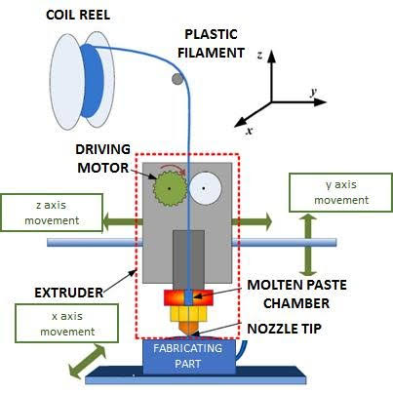

*Figure 1.1: Fused Deposition Modelling.*

* 1. **HISTORY AND SPECIFICATIONS OF PETG MATERIAL**

John Whinfield and James Dickson, two British scientists, combined PET and PETG for the first time in 1941. They heated glycols with terephthalic acid using a procedure known as esterification.   
Together, they accomplished a highly sophisticated creation of a long-chain PET molecule that had the ability to form fibres with a high melting point and dissolvability.

PET began to be used widely in the food packaging sector in 1952, and by 1946 it had become a standard material for the textile industry. By 1976, PET was being used to make beer bottles, carbonated drinks, alcohol, and mineral water.

Despite its benefits, there was a need for something more durable and dependable because of its flaws, such as high crystallisation temperatures that made it simple and opaque. Then PETG was established in order to preserve.

PETG, or polyethylene terephthalate glycol-modified, was made by substituting a bigger monomer for ethylene glycol in the molecular chain. The crystallisation that was linked to PET was prevented by cyclohexane dimethanol.

PETG's exceptional mechanical and chemical qualities, along with its durability, allowed it to overtake the market and win over manufacturers.

Depending on the producer and specific review, PETG stands for Polyethylene Terephthalate Glycol-Modified. Its chemical formula is (C10H8O4)n. PETG is a copolymer of PET, with the addition of glycol to modify its properties. Its characteristics might alter. A malleable quality run tensile strength of 50 MPa to 80 MPa, a flexural strength of 70 MPa to 120 MPa, a glass temperature run of 80°C to 85°C, the melting point is ranging from 260°C to 280°C, and the density of PETG typically ranges from 1.27 to 1.35 g/cm³ are a few common characteristics, in spite of the fact that.

* 1. **POLYETHYLENE TEREPHTHALATE GLYCOL (PETG) ADVANTAGES**

Polyethylene terephthalate glycol (PETG) is a thermoplastic polyester resin that offers several advantages, making it a popular choice for various applications:

1. Flexibility: PETG possesses a degree of flexibility, allowing it to bend without breaking easily. This flexibility makes it suitable for applications where some degree of deformation or flexing is expected, such as in flexible packaging or parts subjected to bending forces.
2. Toughness: PETG exhibits high toughness, meaning it can absorb a significant amount of energy before failure. This property makes it resilient to impacts, making it ideal for applications where resistance to sudden loads or impacts is crucial, such as in protective casings or safety equipment.
3. Creep Resistance: PETG has good creep resistance, meaning it can maintain its shape and dimensional stability under prolonged mechanical stress or load. This property is important for applications where the material will be subjected to constant loads over time, preventing deformation or sagging.
4. Fatigue Resistance: PETG shows good resistance to fatigue, meaning it can withstand repeated loading cycles without undergoing significant degradation in mechanical properties. This property is advantageous in applications subjected to cyclic loading or vibrations, ensuring long-term durability and reliability.
5. Abrasion Resistance: PETG offers moderate abrasion resistance, allowing it to withstand wear and tear from frictional forces over time. While not as abrasion-resistant as materials like nylon or acetal, PETG still maintains its mechanical integrity in applications where moderate abrasion resistance is required.
6. Dimensional Stability: PETG exhibits good dimensional stability, meaning it retains its shape and size over a wide range of temperatures and environmental conditions. This property is important for maintaining tight tolerances in precision-engineered parts and assemblies.
7. High Strength-to-Weight Ratio: PETG offers a favorable strength-to-weight ratio, providing adequate strength and mechanical performance while keeping the overall weight of the component or product low. This characteristic is advantageous in applications where weight savings are important, such as in aerospace or automotive components.
8. Impact Resistance: PETG has good impact resistance compared to other thermoplastics like acrylic or polycarbonate. It can withstand moderate to heavy impacts without shattering, making it suitable for applications where durability is crucial.
9. Chemical Resistance: PETG exhibits resistance to a wide range of chemicals, including acids, bases, and solvents. This property makes it suitable for applications where exposure to chemicals is expected, such as in laboratory equipment or chemical storage containers.
10. Ease of Fabrication: PETG is easy to fabricate using common plastic processing techniques such as injection molding, extrusion, and thermoforming. Its ease of processing allows for efficient manufacturing of various products with complex shapes and designs.
11. Recyclability: PETG is recyclable, which contributes to sustainability efforts. It can be easily recycled and reused in the production of new PETG products or other plastic products, reducing environmental impact.

Overall, the PETG a versatile material for a wide range of applications in various industries, where its combination of toughness, flexibility, fatigue resistance, and other mechanical properties meets the specific requirements of the application.

* 1. **ADVANTAGES OF USING 3D PRINTING**

3D printing, also known as additive manufacturing, offers numerous advantages across various industries and applications:

1. Design Flexibility: 3D printing enables the creation of highly complex geometries that are difficult or impossible to achieve with traditional manufacturing methods. This design freedom allows engineers and designers to optimize parts for specific functions, reduce material usage, and create lightweight yet strong structures.
2. Rapid Prototyping: 3D printing allows for rapid prototyping, significantly reducing the time and cost required to iterate on designs. Engineers can quickly produce physical prototypes for testing and validation, accelerating the product development process and enabling faster time-to-market.
3. Customization and Personalization: 3D printing enables on-demand manufacturing of customized products tailored to individual needs and preferences. This capability is particularly valuable in industries such as healthcare, where personalized medical devices and implants can improve patient outcomes.
4. Reduced Waste: Unlike traditional subtractive manufacturing methods, which often result in significant material wastage, 3D printing is an additive process that only uses the amount of material required to build the part. This reduces material waste and contributes to sustainability efforts.
5. Cost-Effective for Low-Volume Production: 3D printing is cost-effective for low-volume production runs, as it eliminates the need for expensive tooling and setup costs associated with traditional manufacturing processes. This makes it economically viable to produce small batches of customized or niche products without incurring high upfront expenses.
6. Complex Assemblies Consolidation: 3D printing enables the consolidation of multiple parts into single assemblies, reducing the need for assembly and fasteners. This simplifies manufacturing processes, lowers assembly costs, and improves the overall reliability of the final product.
7. Innovative Material Options: Advances in 3D printing technology have expanded the range of materials that can be used, including metals, ceramics, composites, and biocompatible polymers. This opens up new possibilities for applications in industries such as aerospace, healthcare, and automotive.
8. Educational and Research Applications: 3D printing is widely used in educational institutions and research laboratories for teaching, experimentation, and academic research. It provides students and researchers with hands-on experience in product development, material science, and manufacturing technology.

Overall, the advantages of 3D printing include design flexibility, rapid prototyping, customization, reduced waste, cost-effectiveness for low-volume production, complex assemblies’ consolidation, on-demand manufacturing, geographical independence, innovative material options, and educational and research applications. These benefits make 3D printing a valuable tool across a wide range of industries, from aerospace and automotive to healthcare and consumer goods.

* 1. **OPTIMIZATION**

Finding the optimal answer to a problem based on a set of restrictions and goals is called optimization. Finding the most practical and cost-effective solution is the goal of optimization in mechanical engineering, which is used to build and enhance systems and products. In mechanical engineering, optimization can take many different forms.

1. Design optimization: This type of optimization involves making improvements to a system's or product's design in order to increase performance. Finding the ideal mix of design parameters, such as size, materials, and geometries, is known as design optimization.
2. Process optimization: This kind of improvement is used to increase the effectiveness of manufacturing processes. The goal of process optimization is to reduce waste and enhance efficiency by selecting the optimal set of process variables, such as temperature, pressure, and feed rates.
3. Multi-objective optimization: This method of optimization is used to simultaneously improve weight, cost, and performance. The goal of multi-objective optimization is to discover the ideal compromise between competing goals.
4. Topology optimization: This type of optimization involves enhancing the topology or shape of a system or product in order to produce the desired performance. Topology optimization is the process of creating optimal shapes or topologies that satisfy specific performance requirements utilizing algorithms.
5. Parameter optimization: is the process of improving a group of parameters in a simulation or model. Finding the ideal set of parameters to produce a desired performance or output is known as parameter optimization.
6. Sensitivity analysis: This method of optimization is used to determine which variables in a simulation or model are most crucial. Sensitivity analysis entails changing a model's or simulation's input parameters to see how they affect the result.
   1. **ADVANTAGES OF OPTIMIZATION**
7. Enhanced Efficiency: Finding the best feasible solution with limited resources through optimisation helps to increase efficiency. It lessens waste, lowers expenses, and increases productivity. Organisations can increase productivity and efficiently use resources by optimising processes, operations, or systems.
8. Cost reduction: Optimisation makes it possible to save costs by locating inefficiencies and getting rid of pointless expenditures. Reduced costs and increased profitability are the results of it helping to optimise supply chain management, production procedures, logistics, and other operational factors.
9. Better Decision-Making: Optimisation models offer quantitative insights and decision help based on data. They aid in weighing trade-offs, assessing various circumstances, and choosing the best course of action. Strategic planning, resource allocation, risk management, and other decision-making processes benefit from optimisation, which produces superior results.
10. Enhanced Performance: Complex systems or processes may be optimised using optimisation techniques to increase performance. Organisations can optimise workflows, optimise algorithms, or adjust parameters to provide higher-quality outputs with quicker turnaround times, more accuracy, and better overall performance.
11. Increased Competitiveness: By allowing organisations to run more effectively, cut expenses, and provide better goods or services, optimisation gives them a competitive edge. Organisations may grow market share, boost customer happiness, and beat rivals by optimising their processes.
12. Effective resource allocation is made possible via optimisation. It helps in deciding how best to allocate money, people, tools, and other resources in order to get the intended results. This is very helpful for things like project management, portfolio optimisation, and staffing.
13. Risk reduction: Risk analysis and optimisation under uncertainty may be incorporated into optimisation models. By taking into account numerous aspects, restrictions, and uncertainties in the decision-making processes, they assist organisations in assessing and mitigating risks. Finding reliable solutions that are resistant to interruptions or uncertainties is made easier through optimisation.
14. Sustainability: By maximising energy usage, waste reduction, and environmental effect, optimisation approaches may support sustainable practises. Organisations may reduce their carbon footprint and adopt more ecologically friendly practises by optimising their supplier chains, transportation routes, and manufacturing processes.

Overall, optimisation has several benefits, including improved decision-making, cost savings, greater competitiveness, performance enhancement, resource allocation, risk reduction, and sustainability. It is an effective technique that may lead to substantial advancements in a variety of fields.

**CHAPTER 2: LITERATURE SURVEY**

* **Balwant Singh** et. al., conducted an extensive literature review to explore the different types of Polymer Matrix Composite (PMC) materials utilized in the context of 3D printing. The study focused on investigating the mechanical properties and other characteristics of composites produced through 3D printing processes. Furthermore, the researchers compared the impact of different composite materials and production techniques on the resulting mechanical properties. They also highlighted the potential of hybrid materials to enhance the mechanical, tribological, and morphological qualities of the final product. The outcomes of this study can serve as a valuable reference for future researchers interested in the development of composite materials.
* **Muammel M. Hanonetal** et al., investigate the impact of different 3D printing processes on the tensile strength and hardness properties of PLA polymer. The researchers employed the fused deposition modelling (FDM) approach to create testing specimens, varying the build orientation, raster direction angle, and layer height. By evaluating the performance of the printed samples under different conditions, a correlation between hardness and tensile strength was established. The results revealed that specimens with an On-edge orientation exhibited the highest Young's modulus and ultimate tensile strength values, measuring at 1.896 ± 0.044 GPa and 49.12 ± 0.78 MPa, respectively. Additionally, the specimen with a layer thickness of 0.1 mm demonstrated the highest elongation at break, reaching 3.13%.
* **Wenzhao Wang** et al., utilised the fused deposition modelling (FDM) technology to prepare the composite scaffolds of polylactic acid (PLA) and nano-hydroxyapatite (n- HA). The composite scaffold was optimized by material characterization, mechanical property test, and in vitro bone marrow mesenchymal stem cells biocompatibility test. Finally, a rabbit model was established to evaluate the osteogenic ability of PLA/n-HA scaffolds in vivo. The results indicated that the PLA/n-HA composites proposed in this study were highly printable, and the printed scaffold showed tunable mechanical strength accompanied by the proportion of n-HA components. The biocompatibility and osteogenic induction properties were proved better than that of the pure PLA scaffold.
* **Xin Wang** et. al., explored various 3D printing techniques for polymer composite materials, including fused deposition modelling, selective laser sintering, inkjet 3D printing, stereolithography, and 3D plotting. The research emphasized the technology involved in manufacturing particle, fiber, and nanomaterial-reinforced polymer composites. The authors successfully demonstrated the feasibility of 3D printing glass fiber and carbon fiber composite compositions using generated 3D models. Furthermore, they discussed the potential applications of these composites in diverse fields such as biomedical, electronics, and aerospace engineering.
* **Ajay Kumar** et al., investigated the impact of process parameters, namely infill density, print speed, and layer height, on the tensile strength of CFRF (Carbon Fiber Reinforced Filament) using PLA thermoplastic. The experiment was designed using the Taguchi L9 design, which consisted of nine parameters. Nine sets of tensile specimens were fabricated following the ASTM standard.The obtained results determined the working ranges for the process parameters as follows: 40%, 60%, and 80% for infill density, 60 mm/s, 80 mm/s, and 100 mm/s for print speed, and 100, 200, and 300 microns for layer height. The optimal tensile strength achieved through the experimentation was found to be 21.961 MPa.
* **Yahia Halabi** et all, experimentally studied the process parameters namely fiber tensile strength, polymer tensile strength, layer thickness, fiber volume fraction, fiber form, infill pattern, and fiber orientation. MATLAB software was used to codify and implement the ABC algorithm and ANN modelling technique. The results shows that good accuracy of this model, R2 values for training, validation, and testing datasets were 0.96, 0.90, and 0.90, respectively; while the RMSE values for training, validation, and testing datasets were 26.71 Mpa, 41.72 Mpa, and 43.64 Mpa. e MAE values for training, validation, and testing datasets were 16.49 Mpa, 28.11 Mpa, and 27.11 Mpa.
* **Christine Le** et all studied the effect of layer thickness on the flexural properties of Polylactic Acid (PLA) bone plate implants produced by the FDM technique. Experimental results showed that the flexural strength is inversely proportional to the layer thickness due to the variation of voids in the specimens. A 3D finite element (FE) model was developed using Abaqus/Explicit software by incorporating the Gurson-Tvergaard (GT) porous plasticity model to predict the elastoplastic and damage behaviour of specimens with different layer thicknesses. It was shown that the FE model was able to predict the flexural behaviour of 3D-printed solid plates with a maximum error of 6.13% in the maximum load. The optimal layer height was found to be 0.1 mm, providing both high flexural strength and adequate bending stiffness.
* **Imran Khan** et all studied the effect of FFF processing parameters on the tensile properties of the printed composites was investigated. After preliminary experiments and a literature review, infill density (ID), printing speed (PS), and layer thickness (LT) were selected as the main processing parameters. The tensile strength (TS) and tensile strain (ℇ) were selected as the outputs (responses) of this study. Tensile testing was performed after printing composite tensile samples on Instron Universal Testing Machine (5 KN). An analysis of variance (ANOVA) was also per-formed to check the significance of FFF process parameters. The results concluded that the selected FFF process parameters were significant in the interaction state of both tensile properties.

**CHAPTER 3: OBJECTIVES**

The structural integrity of the joints with crack depends on the length of the crack and its orientation concerning the joint and also the extremity of stresses at the tip of the cracks. These crack tip stresses are defined by stress intensity factor (SIF).

* Modelling and 3D Printing the specimen using Fused Deposition Modelling (FDM).
* To assess the mechanical properties like tensile strength, flexural strength and hardness of the 3D Printed specimen.
* To investigate the microstructural characteristics of the 3D Printed specimen.
* To experimentally investigate the process attributes for 3D Printing of specimen and identify the optimum process parameters using Response Surface Methodology (RSM).
* To arrive at an empirical relation to assess the output response’s tensile strength and flexural strength in 3D printing of the Specimen.
* To select the optimum combination of parameters using Signal-to-Noise ratio (S/N), and Analysis of Variance (ANOVA) is used for indicating the significant parameters and their effect on tensile strength and flexural strength.

# **CHAPTER 4: METHOD AND METHODOLOGY**

Literature survey

Material selection

Modelling

3D printing

Assess the mechanical properties

Optimization of process parameters using RSM

Conclusion

*Figure 4.1: Flowchart depicting the methodology of project work*

# **CHAPTER 5: TAGUCHI TECHNIQUE**

**5.1 TAGUCHI METHOD**

Using Orthogonal Arrays (OA) to run fewer well-balanced experiments with minimised variance, the Taguchi Method combines the Design of Experiments with the optimisation of control settings to get optimal findings. This method keeps the experiment within the permitted ranges of levels and factors, allowing for the determination of the optimal control parameter values. The Taguchi technique is a very successful experimental strategy for reducing the number of trials needed while yet producing insightful data and ideal results.

|  |  |  |  |  |  |  |
| --- | --- | --- | --- | --- | --- | --- |
| **Sl. No.** | **Parameters** | **Units** | **Level 1** | **Level 2** | **Level 3** | **Level 4** |
| 1 | Layer Thickness | mm | 0.15 | 0.20 | 0.25 | 0.30 |
| 2 | Printing Speed | mm/s | 30 | 40 | 50 | 60 |
| 3 | Infill Density | % | 15 | 30 | 45 | 60 |
| 4 | Infill Pattern | - | Gyroid | Support Cube | Line | Honeycomb |

*Table 5.1: Parameters used*

**5.2 FACTORS**

1. Nozzle temperature: The temperature at which a 3D printer's extruder nozzle heats up to melt filament material and enable precise deposition of the material to build a 3D object layer by layer is known as the nozzle temperature. The optimal temperature range for extrusion varies depending on the material. For common filament types, nozzle temperatures typically range from 180℃ to 260℃. In this work, we employed a nozzle temperature of 225℃.
2. Nozzle diameter: In 3D printing, "nozzle diameter" refers to the size of the aperture at the extruder nozzle tip of the printer, which controls the diameter of the filament that is extruded. The nozzle diameter is commonly expressed in millimetres (mm), and, contingent upon the printer model and intended application, can vary from 0.1 mm to 1.0 mm or greater. The nozzle utilised for printing in this investigation has a diameter of 0.4 mm.
3. Infill density: The quantity of material utilised to fill a printed object's internal structure is referred to as infill density in 3D printing. The layer of material printed inside an object's walls or outer shell is called an infill, and it gives the structure solidity and support. In our analysis, we employed an infill density ranging from 15 – 60%.
4. Infill layer height: The thickness of each layer of material deposited by the printer's extruder nozzle during the printing process is referred to as layer height in 3D printing. Given that it directly impacts the final printed object's quality and resolution, it is one of the most crucial 3D printing settings. In our work, we use an infill height of 0.1–0.3 mm.
5. Printing speed: The rate at which the printer's extruder nozzle moves along the X, Y, and Z axes to deposit the melted filament and build each layer of the printed item is referred to as printing speed in 3D printing. We have taken into consideration the range of 30–60 millimetres per second (mm/s), which is the standard unit of measurement for printing speed.
6. Printing orientation: In 3D printing, printing orientation describes how the object is positioned on the printer's build platform. The final printed object's strength, quality, and beauty can all be impacted by orientation.

**5.3 TAGUCHI CHART**

The Taguchi chart provides a visual representation of the experimental results, making it easier to identify the optimal factor levels and assess the robustness of the system. By optimizing the factor settings and reducing the impact of noise factors, the Taguchi method aims to improve product quality, process performance, and customer satisfaction.

|  |  |  |  |  |
| --- | --- | --- | --- | --- |
| **Sl.**  **No.** | **Layer Thickness** | **Printing Speed** | **Infill Density** | **Infill Pattern** |
| **1** | 0.15 | 30 | 15 | Gyroid |
| **2** | 0.15 | 40 | 30 | Support Cube |
| **3** | 0.15 | 50 | 45 | Line |
| **4** | 0.15 | 60 | 60 | Honeycomb |
| **5** | 0.20 | 30 | 30 | Line |
| **6** | 0.20 | 40 | 15 | Honeycomb |
| **7** | 0.20 | 50 | 60 | Gyroid |
| **8** | 0.20 | 60 | 45 | Support Cube |
| **9** | 0.25 | 30 | 45 | Honeycomb |
| **10** | 0.25 | 40 | 60 | Line |
| **11** | 0.25 | 50 | 15 | Support Cube |
| **12** | 0.25 | 60 | 30 | Gyroid |
| **13** | 0.30 | 30 | 60 | Support Cube |
| **14** | 0.30 | 40 | 45 | Gyroid |
| **15** | 0.30 | 50 | 30 | Honeycomb |
| **16** | 0.30 | 60 | 15 | Line |

*Table 5.2: Parameters used*

**5.4 ASTM STANDARDS**

ASTM International, formerly known as the American Society for Testing and Materials, is an international standards organization that develops and publishes voluntary consensus standards for a wide range of industries and materials. ASTM standards provide specifications, test methods, practices, guides, and terminology that help ensure product quality, safety, and performance. Here is some additional information about ASTM standards.

**5.4.1 TENSILE TEST ASTM D638**

ASTM D638 is an ASTM standard that specifies the test method for determining the tensile properties of plastics using a standard tensile test specimen. The tensile test provides valuable information about the mechanical behaviour of plastics under tension, including their strength, elongation, modulus of elasticity, and other related properties.

**5.4.2 FLEXURAL TEST ASTM D7264**

ASTM D7264 is an ASTM standard that specifies the test method for flexural properties of polymer matrix composite materials using a three-point bending test. This test method provides information about the flexural modulus, strength, and deformation characteristics of composite materials under bending loads.

|  |  |
| --- | --- |
| **Test Method** | **Method number** |
| Tensile test | ASTM D638 |
| Flexural test | ASTM D7264 |

*Table 5.3: Parameters used*

**5.5 MODELLING**

**5.5.1 2D MODELLING IN CAD.**

A 2D CAD model is a digital representation of a design or object created using computer-aided design (CAD) software. It consists of two-dimensional shapes and lines that accurately depict the object's dimensions, proportions, and details. Here is some additional information about 2D CAD models. It's important to note that while 2D CAD models provide detailed information about the object's shape and dimensions, they lack the additional depth and spatial information offered by 3D CAD models. However, 2D models are still valuable for many design and documentation purposes, especially when working with 2D representations is sufficient or necessary due to project requirements.

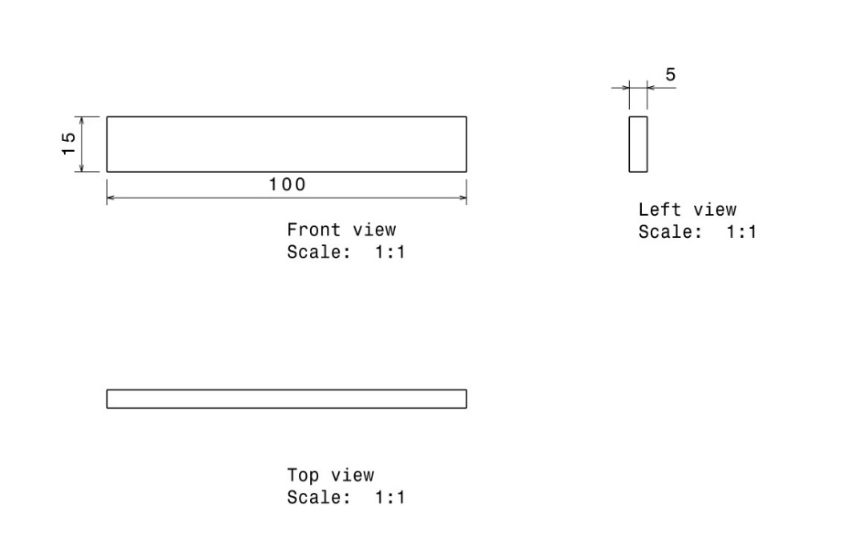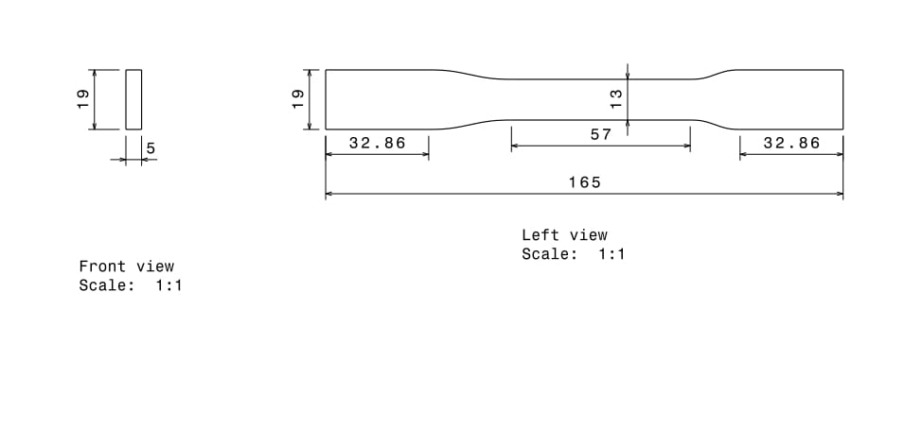 *Figure 5.1: Tensile test specimen drawing.*

*Figure 5.2: Flexural test specimen drawing.*

**4.5.2 3D MODELING IN CAD.**

The process of creating a 3D CAD model typically involves sketching or creating 2D profiles, which are then extruded, revolved, or manipulated to form 3D shapes. Additional features like fillets, chamfers, holes, and patterns can be added to enhance the design. 3D CAD models are composed of various geometric entities, such as points, lines, surfaces, and solids. These entities are used to define the shape, contours, and features of the object being modelled.

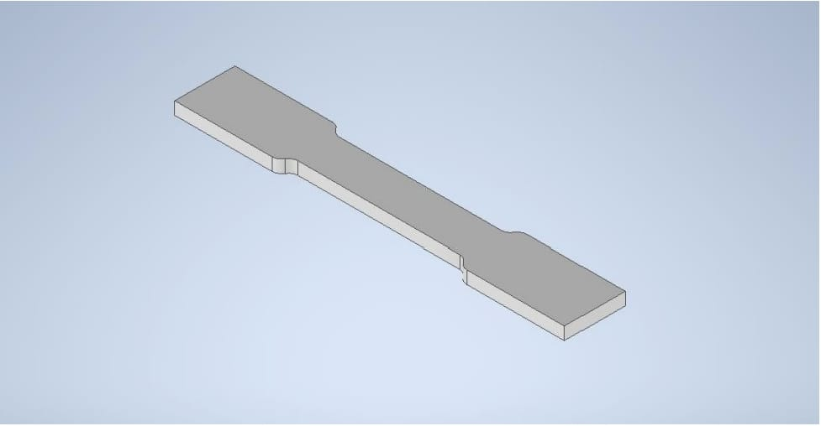

*Figure 5.3: Tensile test specimen model.*

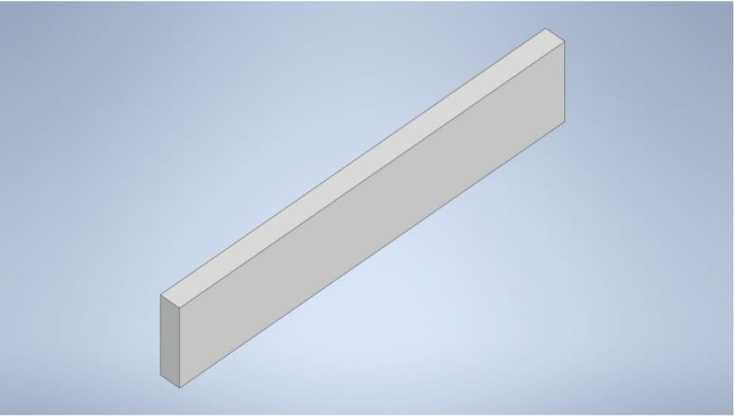

*Figure 5.4: Flexural test specimen model.*

**5.6 SLICING PROCESS.**

**5.6.1 SLICING SOFTWARE**

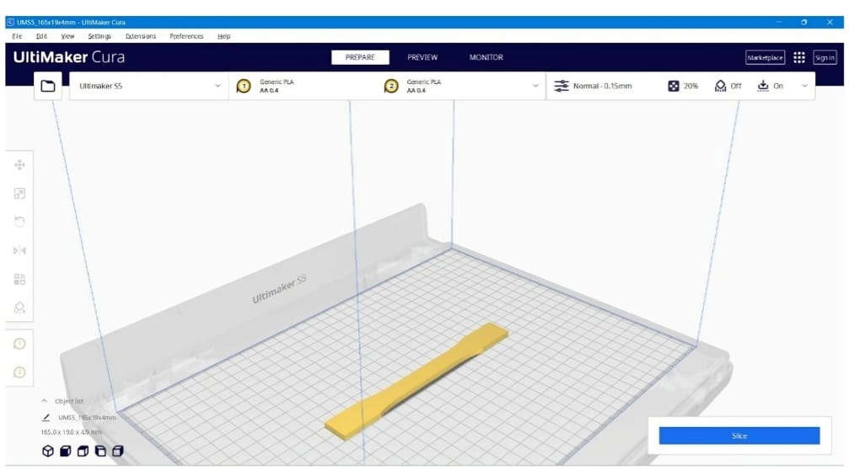Cura is a popular slicing software used in 3D printing. It is developed and maintained by Ulti maker, a leading manufacturer of 3D printers. Cura provides a user-friendly interface and powerful tools to prepare 3D models for printing. Here's some information about Cura software. Cura is primarily used as a slicing software. Slicing is the process of converting a 3D model into a series of 2D layers that a 3D printer can understand and print. Cura takes the 3D model and generates the instructions (G-code) necessary for the printer to create the object layer by layer.

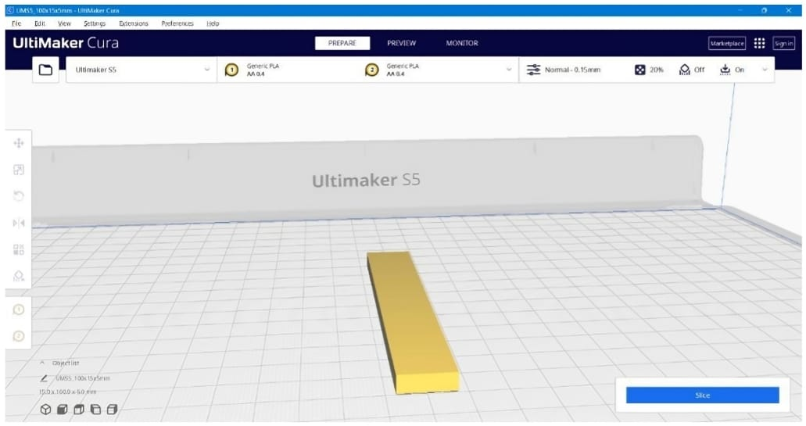*Figure 5.5:* *Slicing of tensile specimen.*

*Figure 5.6:* *Slicing of flexural specimen.*

**5.6.2 PRINTING PATTERN**

In 3D printing, the lines pattern refers to the visible layer lines that are typically present on the surface of a printed object. These lines are the outcome of 3D printing's layer-by-layer additive manufacturing technique. A 3D model that has been thinned out is printed layer by layer, beginning at the bottom and working your way up. To construct each layer, the printer continuously extrudes material, such plastic filament. A solid structure is formed as the material fuses and solidifies during the depositing process.

Because of the gradual nature of the printing process, the pattern of lines becomes visible. There is a stair-step effect because each layer is marginally displaced from the one before it. The layer lines, which trace the course of the printer nozzle, show up as ridges or grooves on the printed object's surface. A number of variables, including as the layer height (thickness), print speed, nozzle size, and overall print quality, affect how visible and prominent the lines pattern is. Smoother surfaces with fewer apparent lines are usually produced by using finer layer heights and slower print rates.   
On the other hand, sharper lines may result from higher layer heights and quicker print times.

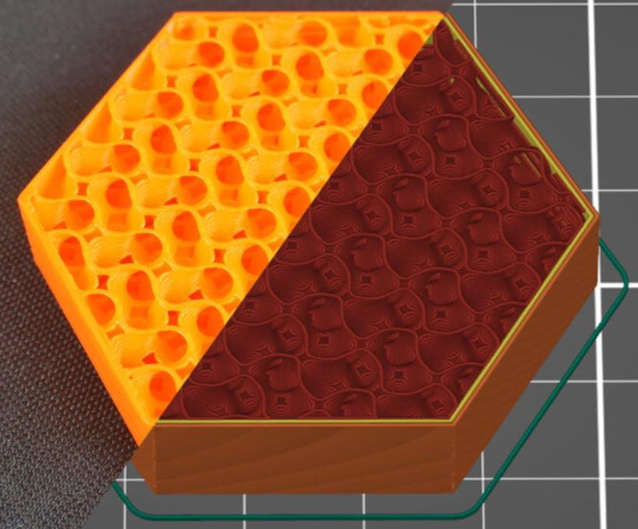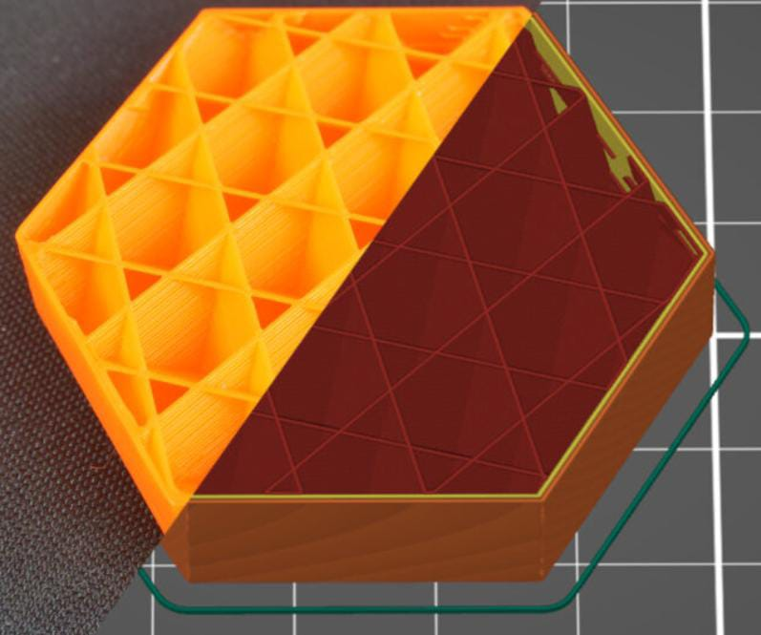

1. *(ii)*

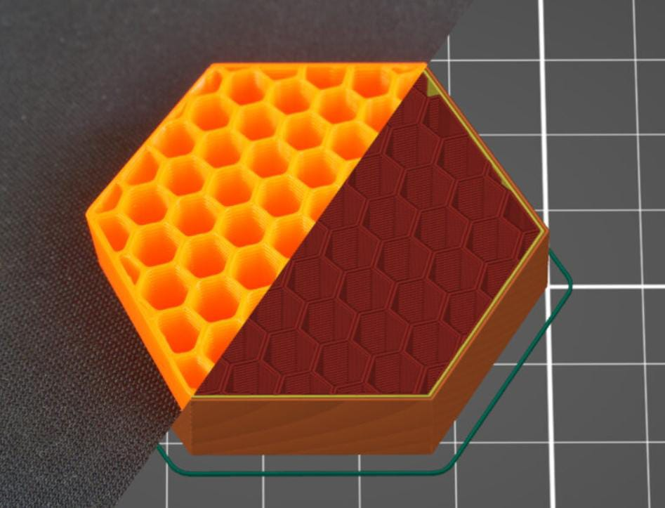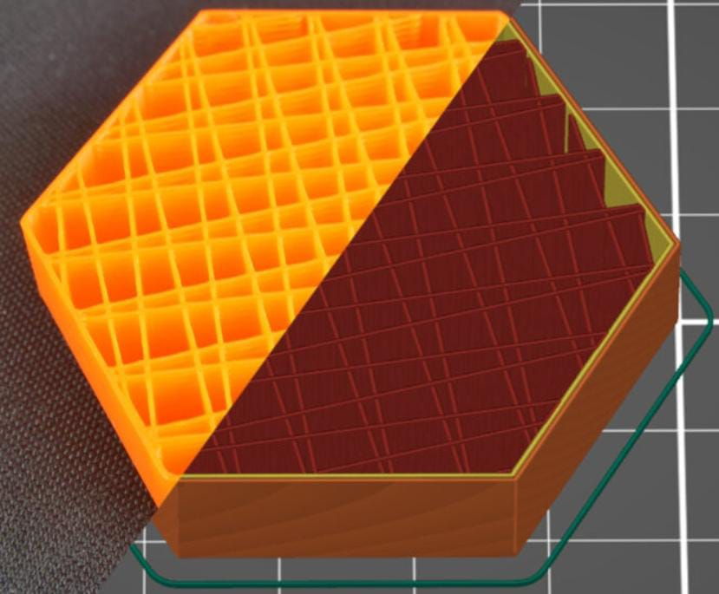

*(iii) (iv)*

*Figure 5.7:**Printing pattern – (i)* *Gyroid; (ii)* *Support Cube; (iii)* *Line; (iv)* *Honeycomb*

**5.7 PRINTING FILAMENT.**

PETG (Polyethylene Terephthalate Glycol) is highly sought after for its excellent mechanical strength and resistance to water intrusion and chemical attack. PETG combines some of the good qualities of two other well-known thermoplastic materials used for 3D printing: ABS (acrylonitrile butadiene styrene) and PLA (Polylactic Acid). ABS is known for its durability and PLA for its printability.

Polyethylene terephthalate glycol, or PETG for short, is a modification of PET (polyethylene terephthalate). The chemical group cyclohexanedimethanol (CHDM) largely replaces the ethylene glycol in PET. The research conducted in 1941 by two British scientists, John Whinfield and James Dickson, is where PETG had its start. PETG is a substance safe for food. It is therefore in demand in the food and beverage industries as a packaging product. Retail signage is another common application for PETG. PETG is less likely to distort and more affordable than materials like ABS. The features, composition, suggested printer settings, and contrasts with alternative 3D printing filaments will all be covered in this paper.

|  |  |
| --- | --- |
| Chemical Structure | * PETG belongs to the family of polyester. * Chemical formula: (C10H8O4)n |
| Physical Properties | * Density: 1.28 g/cm³ * Melting Point: 220°C - 260°C * Glass Transition Temperature (Tg): 80°C |
| Mechanical Properties | * Tensile Strength: 50 Mpa. * Flexural Strength: 74 Mpa. * Hardness (Rockwell): 71 HRM |
| Thermal Properties | * Thermal Conductivity: 0.162 – 0.225 W/m-K |

*Table 2: P*

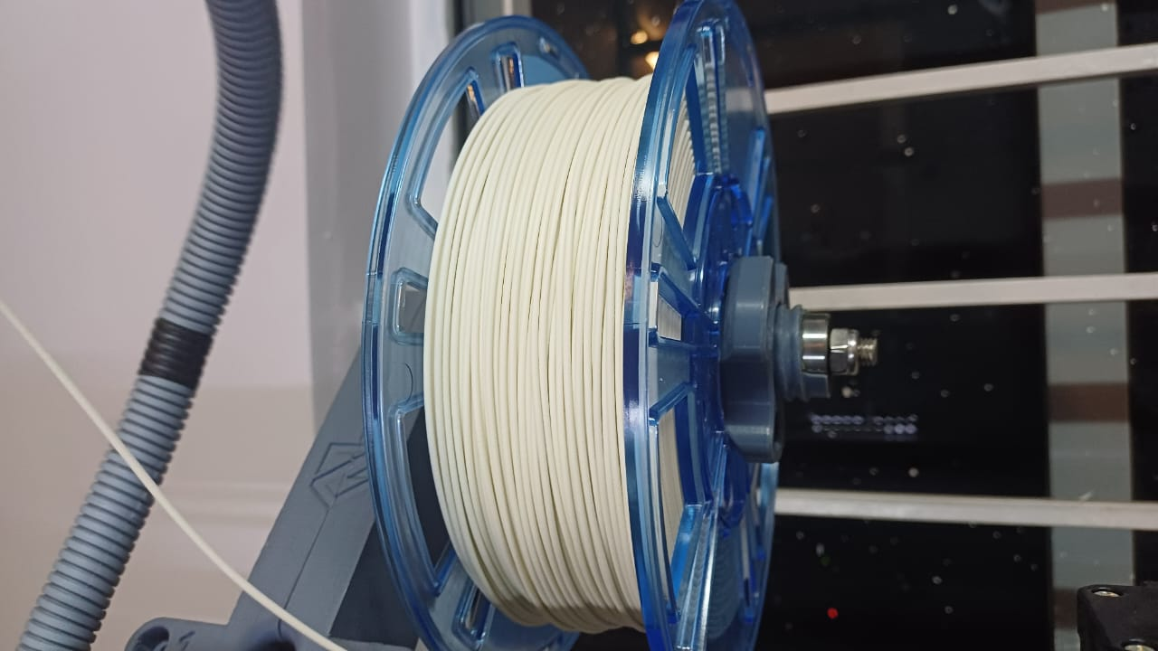 *Figure 5.8:**Polyethylene terephthalate glycol (PETG) filament*

**5.8 PRINTING PROCESS.**

3D Printing Process forPolyethylene terephthalate glycol (PETG):

1. Preparation of 3D Printer: Make sure your 3D printer is properly calibrated and clean. PETG prints best on a heated print bed, typically set between 70°C to 85°C. Additionally, some printers may benefit from an enclosure to maintain stable printing conditions.
2. Filament Loading: Load the PETG filament into the 3D printer's filament holder and feed it into the extruder according to the manufacturer's instructions.
3. Slicer Settings: Use a slicer software (e.g., Cura, Simplify3D) to generate the G-code for your 3D model. PETG prints best with a nozzle temperature between 230°C to 250°C. Adjust the printing speed, layer height, and cooling settings according to your specific printer and filament.
4. Bed Adhesion: PETG tends to stick well to heated glass print beds coated with materials like Build Tak or PEI. Ensure proper bed leveling and use adhesion aids like a thin layer of glue stick or specialized bed adhesion sprays if needed.
5. Printing: Start the printing process. PETG tends to ooze more than other filaments, so consider using a skirt or brim to prime the nozzle before printing the actual model. Monitor the first layer closely to ensure proper adhesion to the print bed.
6. Cooling: PETG benefits from minimal cooling during printing. Unlike PLA, which requires active cooling to prevent warping, PETG should be printed with minimal to no cooling fan. However, some printers may benefit from a fan running at a low speed for small, intricate details.
7. Post-processing: After the print is complete, allow it to cool on the print bed before removing it. PETG prints tend to be more flexible than PLA or ABS, so take care when removing supports or rafts to avoid damaging the print.
8. Finishing: PETG prints can be sanded and painted if desired. Sanding can help smooth out layer lines and imperfections, while painting can add colour and texture to the finished print.
9. Storage: Store PETG filament in a dry, cool place away from direct sunlight to prevent moisture absorption, which can affect print quality.

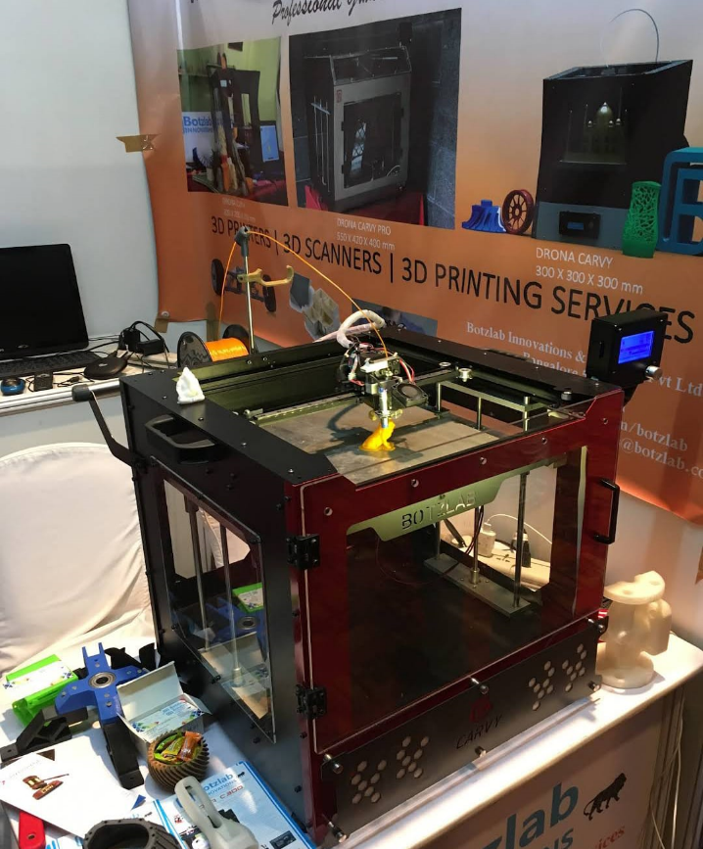By following these steps and adjusting settings as needed for your specific printer and filament, you should be able to achieve successful 3D prints with PETG.

*Figure 5.9:**3D printer used for additive manufacturing*

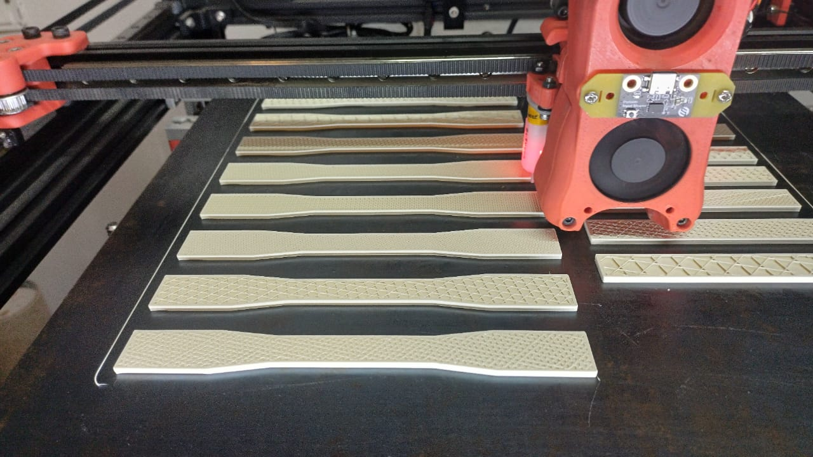

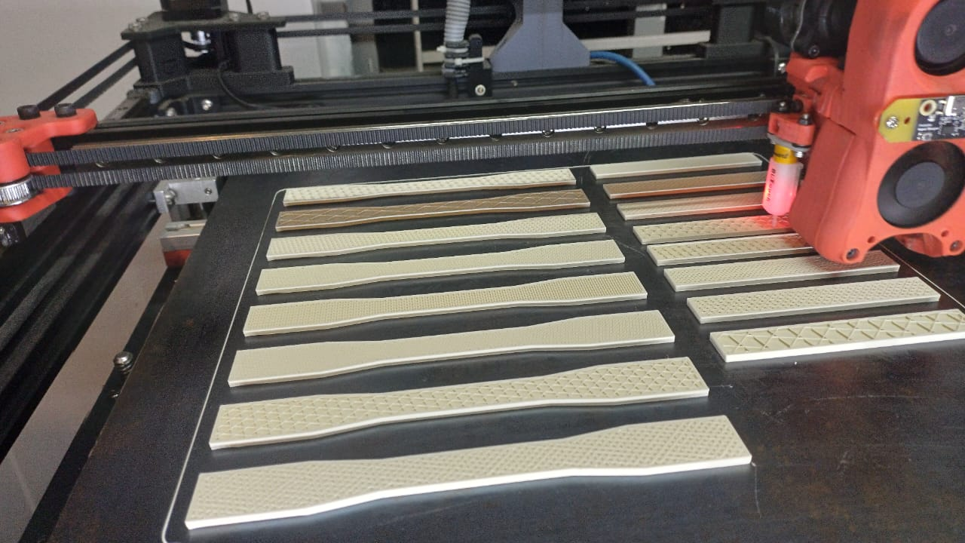

*Figure 5.10:* ***S****pecimens being printed*

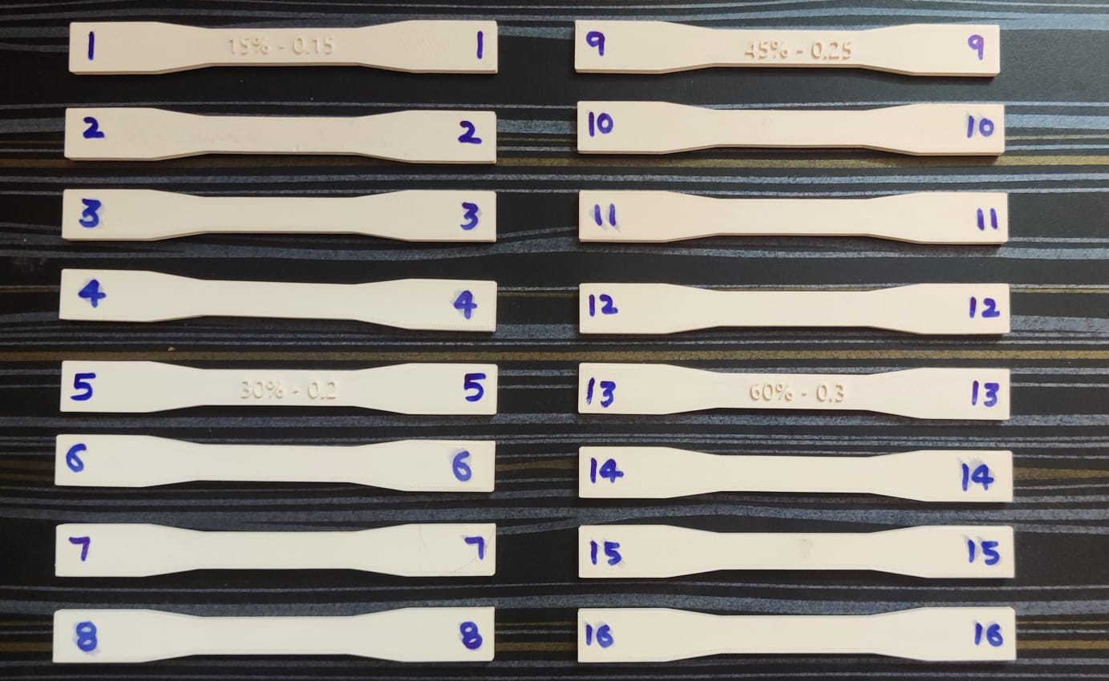

*Figure 5.11:* *3D printed Tensile specimen*

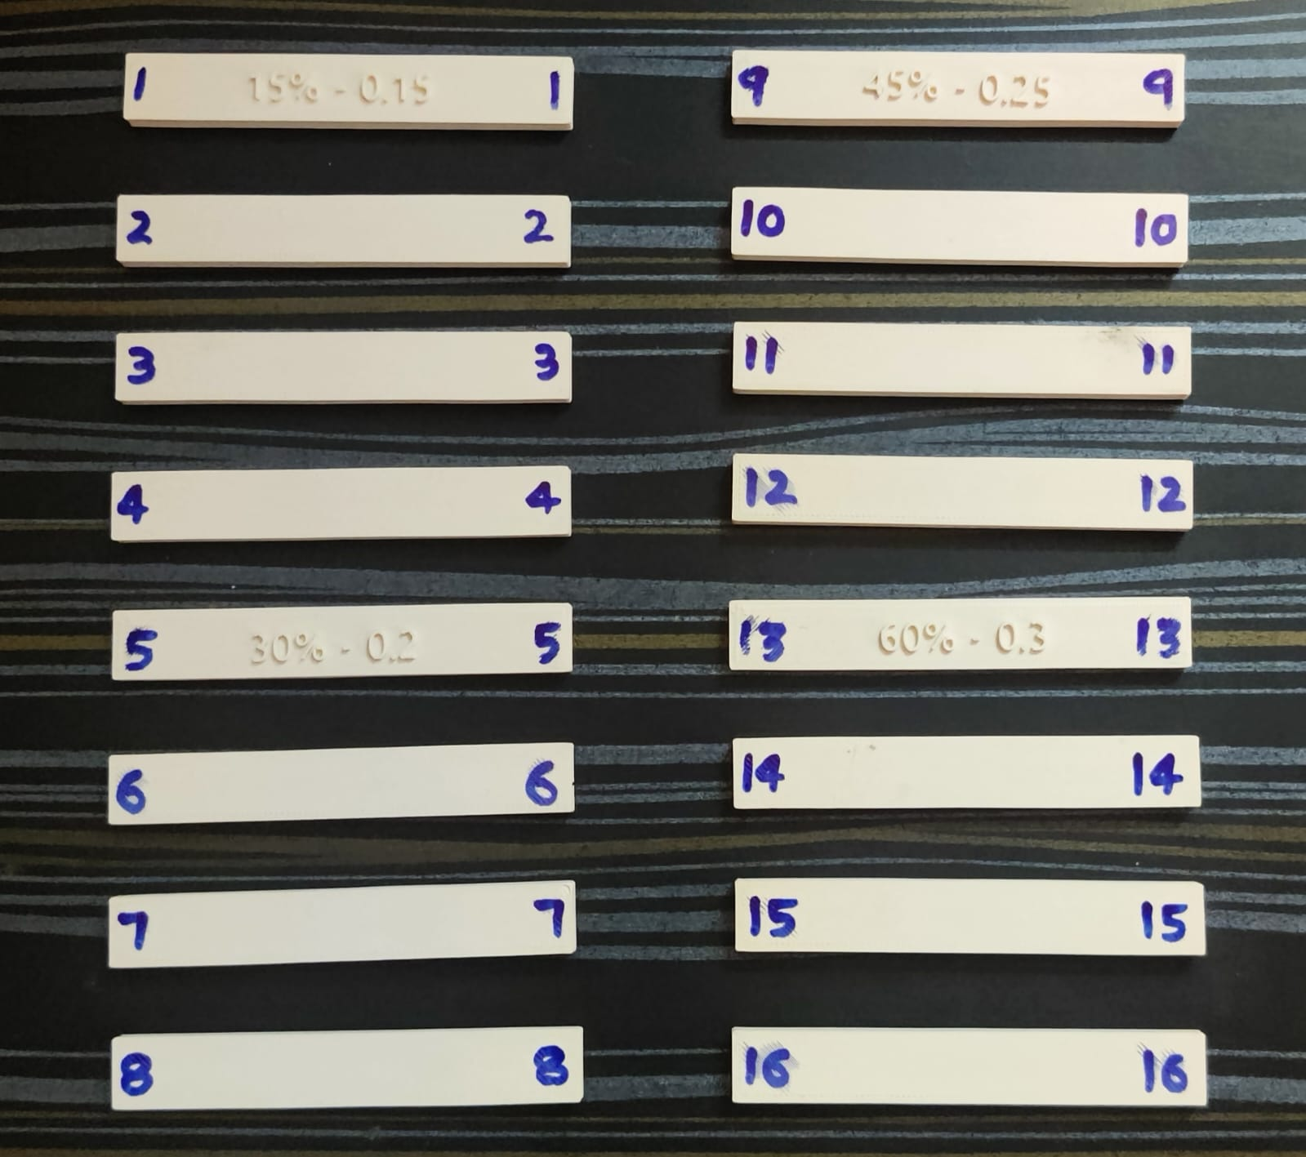

*Figure 5.12:* *3D printed Flexural specimen*

**5.9 EXPERIMENTATION**

**5.9.1 TENSILE TEST**

A tensile test, also known as tension test or pull test, is a fundamental mechanical test performed on materials to understand how they respond to applied forces. It helps in determining key properties such as strength, elasticity, ductility, and toughness.

* Sample Preparation: Prepare dog bone-shaped specimens with specific dimensions according to the applicable standards or your experimental requirements.
* Mounting: The specimen is mounted onto a testing machine, often called a universal testing machine, equipped with grips or clamps that hold the specimen securely.
* Preload: Apply a small initial load to remove any slack and ensure proper contact between the grips and the specimen.
* Test Parameters: Define the testing speed (usually specified in standards) and gauge length (the initial length of the specimen from which strain is measured).
* Test Execution: Start the test machine to apply a uniaxial tensile force to the specimen until it fractures.
* Data Collection: Measure and record the load (force) and elongation (strain) at regular intervals or until the specimen fails.

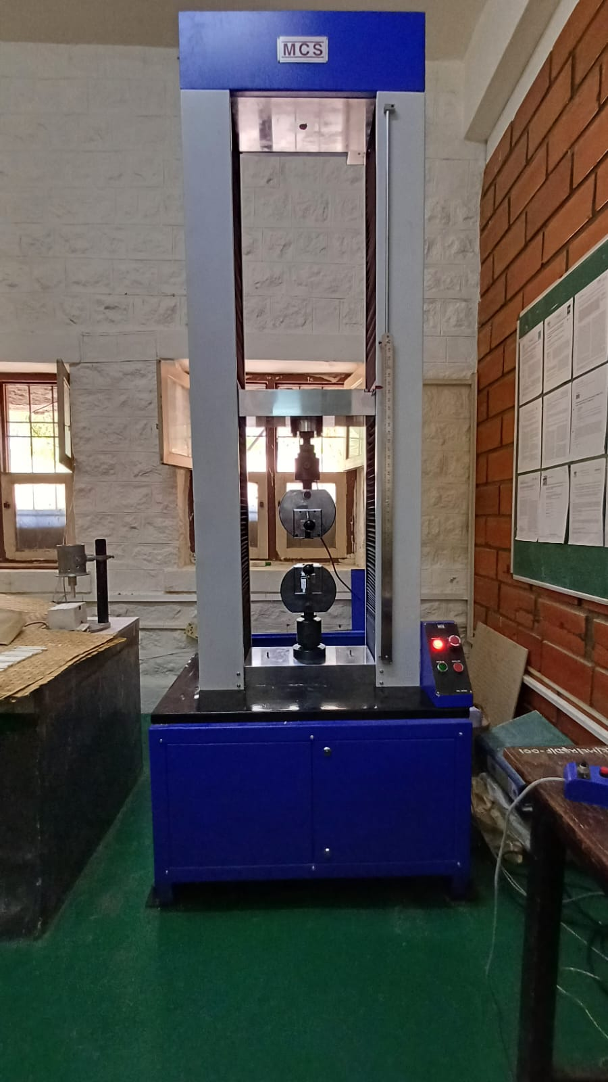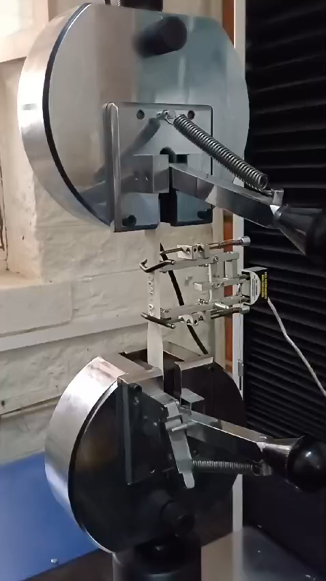

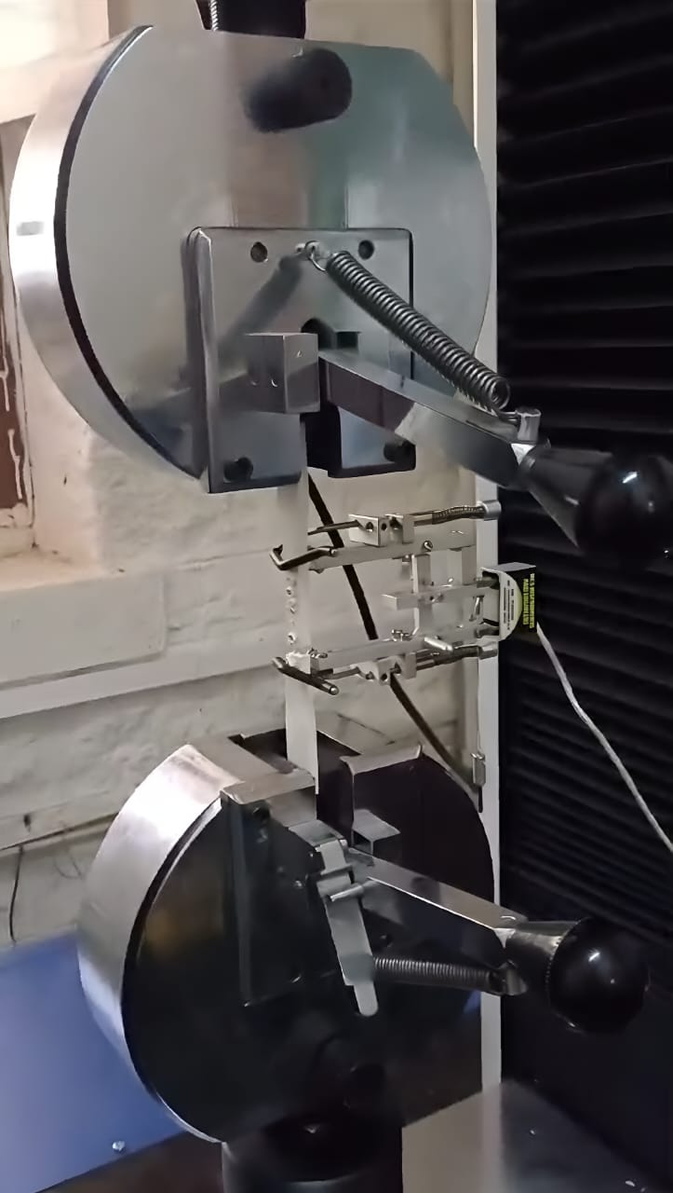*Figure 5.13:* *Universal testing machine*

*Figure 5.14:* *Breaking of Tensile specimen*

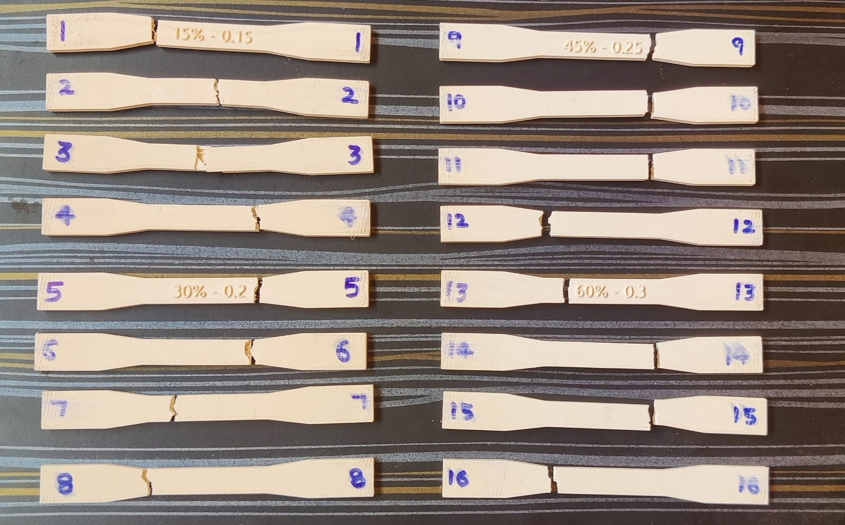

*Figure 5.15: Tensile specimen*

|  |  |  |  |  |  |
| --- | --- | --- | --- | --- | --- |
| **Sl.**  **No.** | **Layer Thickness (mm)** | **Printing Speed (mm/s)** | **Infill Density**  **(%)** | **Infill Pattern** | **Tensile Strength**  **(N/mm2)** |
| **1** | 0.15 | 30 | 30 | Gyroid | 16.691 |
| **2** | 0.15 | 40 | 40 | Support Cube | 18.843 |
| **3** | 0.15 | 50 | 50 | Line | 20.613 |
| **4** | 0.15 | 60 | 60 | Honeycomb | 20.983 |
| **5** | 0.20 | 30 | 30 | Line | 18.122 |
| **6** | 0.20 | 40 | 15 | Honeycomb | 22.997 |
| **7** | 0.20 | 50 | 60 | Gyroid | 22.838 |
| **8** | 0.20 | 60 | 45 | Support Cube | 22.944 |
| **9** | 0.25 | 30 | 45 | Honeycomb | 25.170 |
| **10** | 0.25 | 40 | 60 | Line | 23.792 |
| **11** | 0.25 | 50 | 15 | Support Cube | 22.149 |
| **12** | 0.25 | 60 | 30 | Gyroid | 20.930 |
| **13** | 0.30 | 30 | 60 | Support Cube | 22.202 |
| **14** | 0.30 | 40 | 45 | Gyroid | 23.474 |
| **15** | 0.30 | 50 | 30 | Honeycomb | 24.481 |
| **16** | 0.30 | 60 | 15 | Line | 24.534 |

*Table 3: Experimental results of tensile test*

**5.9.2 FLEXURAL TEST**

A flexural test, also known as a bending test, is another important mechanical test used to evaluate the strength and stiffness of materials, especially those used in structural applications such as beams, columns, and bridges. Unlike a tensile test, which applies a force along the longitudinal axis of a specimen, a flexural test applies a force perpendicular to the longitudinal axis, causing the specimen to bend.

* Sample Preparation: A specimen of the material is prepared with specific dimensions and geometry according to standardized procedures. The specimen is often a beam or a rectangular prism.
* Mounting: The specimen is mounted on supports spaced a certain distance apart. The supports may be simple supports or may allow for varying degrees of restraint, depending on the specific requirements of the test.
* Application of Load: A load is applied to the centre of the specimen, causing it to bend. The load can be applied gradually or in increments, depending on the testing protocol.

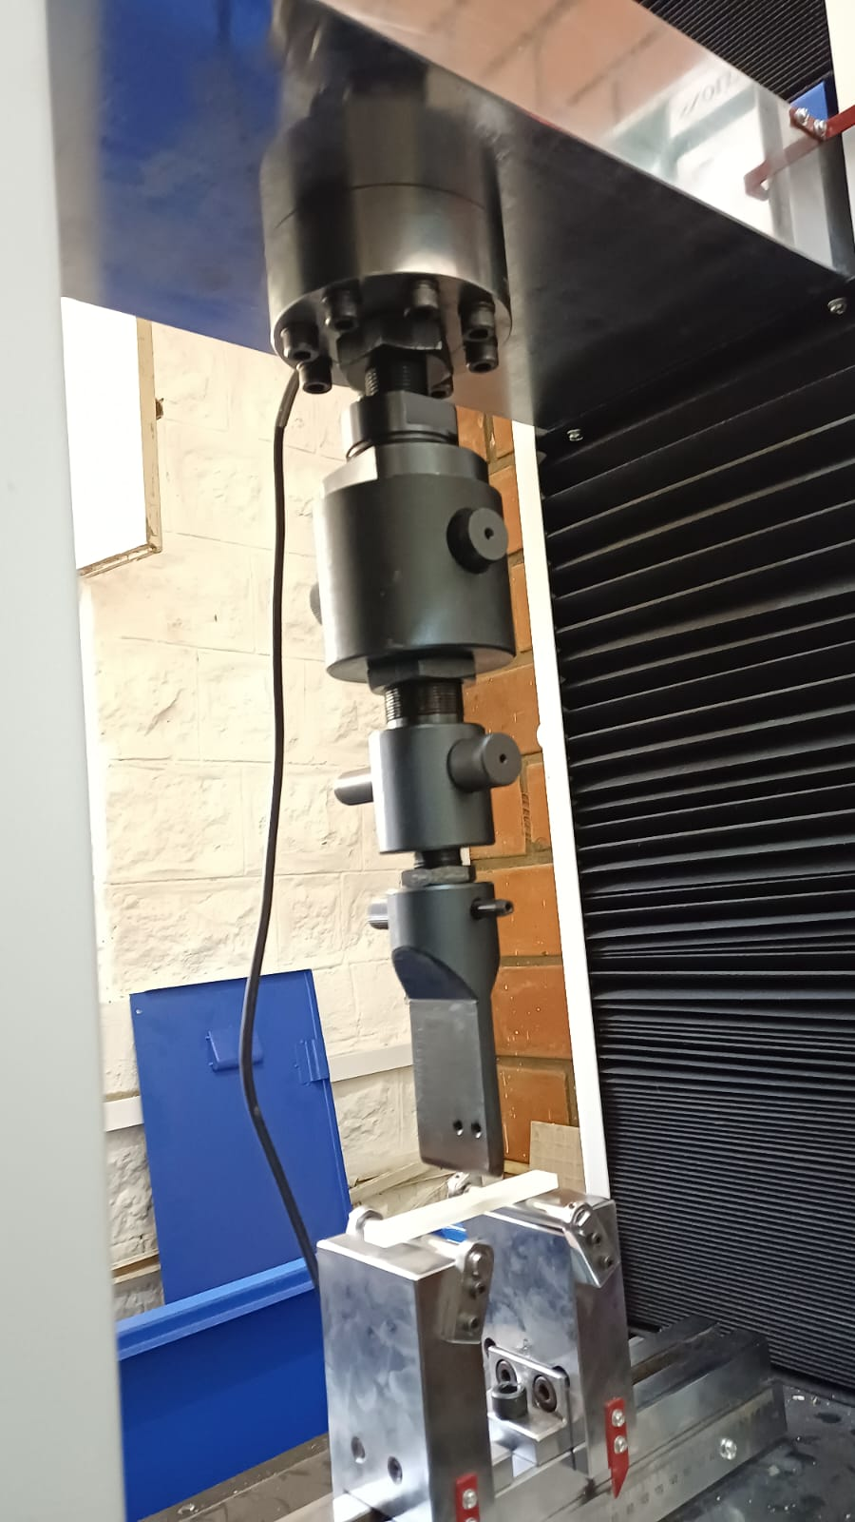

*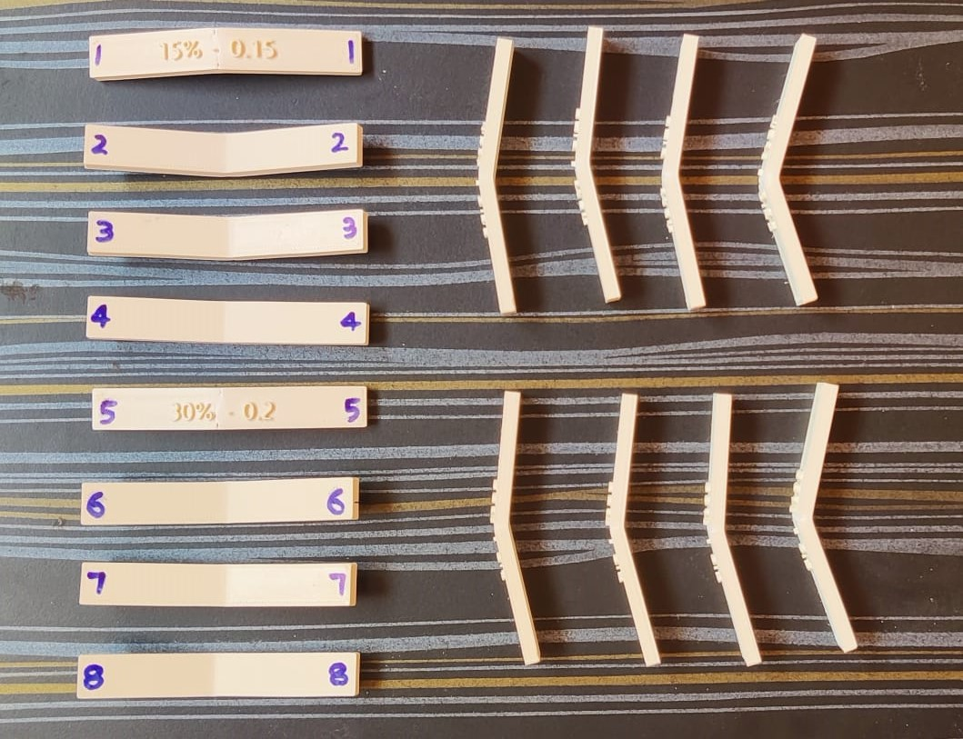Figure 5.16:* *Universal testing machine*

*Figure 5.17: Flexural specimen*

|  |  |  |  |  |  |
| --- | --- | --- | --- | --- | --- |
| **Sl.**  **No.** | **Layer Thickness (mm)** | **Printing Speed (mm/s)** | **Infill Density**  **(%)** | **Infill Pattern** | **Flexural Strength**  **(N/mm2)** |
| **1** | 0.15 | 30 | 30 | Gyroid | 2.891 |
| **2** | 0.15 | 40 | 40 | Support Cube | 3.765 |
| **3** | 0.15 | 50 | 50 | Line | 3.967 |
| **4** | 0.15 | 60 | 60 | Honeycomb | 3.833 |
| **5** | 0.20 | 30 | 30 | Line | 3.967 |
| **6** | 0.20 | 40 | 15 | Honeycomb | 3.967 |
| **7** | 0.20 | 50 | 60 | Gyroid | 3.900 |
| **8** | 0.20 | 60 | 45 | Support Cube | 3.026 |
| **9** | 0.25 | 30 | 45 | Honeycomb | 3.967 |
| **10** | 0.25 | 40 | 60 | Line | 3.698 |
| **11** | 0.25 | 50 | 15 | Support Cube | 4.102 |
| **12** | 0.25 | 60 | 30 | Gyroid | 3.967 |
| **13** | 0.30 | 30 | 60 | Support Cube | 4.034 |
| **14** | 0.30 | 40 | 45 | Gyroid | 3.967 |
| **15** | 0.30 | 50 | 30 | Honeycomb | 3.967 |
| **16** | 0.30 | 60 | 15 | Line | 4.371 |

*Table 4: Experimental results of Flexural test*

**RESPONSE SURFACE METHODOLOGY**

**6.1 UNDERSTANDING RSM**

* + 1. **THE DESIGN OF EXPERIMENTS (DOE)**

Systems or processes can be investigated and analysed using a methodical, scientific methodology called design of experiments (DOE). It is essential to many industries, including manufacturing, scientific research, and the chemical process sector. DOE aids in comprehending the connection between input components (variables) and the final results or responses by meticulously planning and carrying out tests.

DOE's capacity to effectively investigate a large variety of factor combinations while reducing the number of tests needed is one of its main advantages. This is a cost-effective strategy since it saves money and time. Additionally, DOE makes it possible to pinpoint crucial elements that have a big influence on the system or process being studied. DOE aids in enhancing and optimising the robustness, performance, and dependability of processes and products by identifying the ideal factor levels.

Furthermore, DOE offers an organised framework for interpreting and analysing data. It makes it possible for academics to examine experimental data efficiently, spot trends, and come to insightful conclusions. In order to examine the data and provide a measurable and impartial evaluation of the experimental findings, statistical methods are frequently used.

In many different businesses, DOE is seen as an important tool for decision-making. It makes evidence-based decision-making easier by giving precise insights into the effects and interconnections of various elements. Making educated decisions about resource allocation, quality enhancements, and process improvements is made easier with the use of this information.

Designed experiments are carried in four phases:

Planning, Screening, Optimization, Verification.

* + 1. **FACTORIAL DESIGN**

The best method for analysing the combined impact of two or more variables on a particular response variable is known to be a factorial design. Research using 2k factorial designs is common when examining the combined effects of "k" factors on a response variable. These designs are very useful since they enable the analysis of variables at two levels, which might be qualitative (such as high or low levels) or quantitative (such as temperature or time values). Adding "n" centre points, or replicated runs placed in the centre of the design, is an intriguing way to modify 2k factorial designs. It is presumed that the "k" factors are quantitative as these replicated runs at medium factor levels are included. With this innovation, experimenters can assess quadratic impacts (curvature) and get a separate error estimate. Known as a 22-factorial design with five centre points, the initial design of the 2k series consists of two factors, each of which has two levels, and five duplicated runs at the centre point. This method provides the bare minimum of runs required to thoroughly investigate the combined effect of two factors on a response variable.

* + 1. **RESPONSE SURFACE METHODOLOGY**

For optimisation, the response surface technique (RSM) is a widely used experimental design. It provides a useful method for assessing how various factors interact to affect one or more response variables. This approach refers to the observable results as dependent variables and the process-influencing factors as independent variables. Establishing a suitable approximation relationship between the input and output variables is the main objective of RSM since it makes it possible to identify the ideal operating conditions for the system that is being studied. A collection of statistical and mathematical methods known as the response surface methodology (RSM) are useful for modelling and assessing situations in which several variables affect an interest response. The principal aim of RSM is to determine the ideal values of the contributing variables in order to maximise this reaction.

As an illustration, the goal is to ascertain the ideal temperature (x1) and pressure (x2) settings in order to maximise the yield (y) in each process. Figure 1 shows how the response's values fluctuate depending on how the two components are combined. In a two-dimensional plane, these response values are represented by contour lines or response contours; in a three-dimensional representation, they form a response surface. The graph shows that the response values rise as the contour lines are thinner, peaking at the halfway point. The maximum response value, sometimes referred to as the optimal response, can be found by projecting the midpoint onto the response surface.

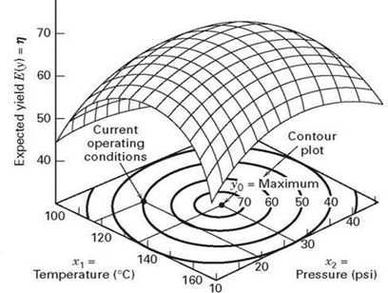

*Figure 6.2:* *Response Surface Methodology*

* + - 1. **First Order Response**

For the present operating conditions, a first-order regression model usually works well, mainly because the current conditions are frequently far from the ideal response settings. The experimenter's goal is to reduce the number of experiments needed in order to effectively transition from the current operating circumstances to the optimal zone. For this, the steepest ascent approach is utilised. This strategy makes it easier to advance towards the ideal conditions by using the contour plot of the first-order model to estimate the parameters for the following experiment. When there are two factors influencing a process's response, the researcher fits the first-order model listed below to investigate the area around the present operating circumstances:

…………………. (i)

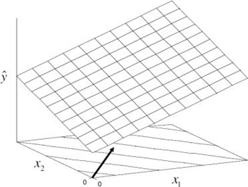

*Figure 6.3:* *First order Response Surface*

* + - 1. **Second Order Response Surface**

When an experiment is discovered to be close to the optimal response zone, it is obvious that a first order model can no longer be used to approximate the response. As a result, a second order model is frequently used. Since third order and higher effects usually have negligible impact, the second order model is usually sufficient for the optimal region. For K factors, the expression for the second order regression model is as follows:

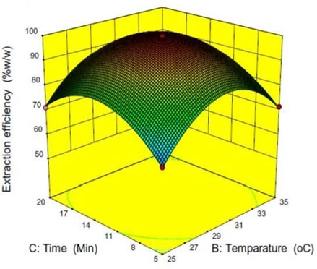

*Figure 6.4:* *Second order Response Surface*

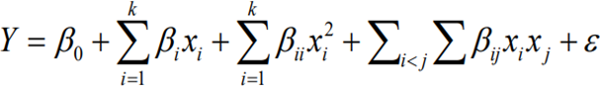……. (ii)

Regression parameters for the model are represented by the formula p = (k+1) (k+2)/2. These coefficients include those for main effects (β1, β2,..., βk), quadratic main effects (β11, β22,..., βkk), and two-factor interaction effects (β12, β23,..., βk-1k). It would be possible to estimate all required regression parameters using a full factorial design, where all components are set at three levels. However, because the number of necessary experimental runs rises quickly with the number of factors, using a full factorial design with three levels for each component can be costly.

* 1. **DIFFERENT STEPS TO IMPLEMENT RSM**

**First Step:** This entails planning and carrying out a first-order experiment, then modelling the collected data with a first-order linear regression. Generally speaking, the factor values used in this experiment match the current machine operating circumstances. For every factor, two levels—often referred to as "high" and "low" values—are typically used. These levels facilitate investigating how the causes affect the response variable under the specified operating conditions**.**

**Second Step:** The response surface is analysed to determine whether the regression model exhibits any lack of fit once the first-order design experiment is completed. The identification of the ideal solution is indicated if there is a lack of fit. On the other hand, if there is no evidence of a lack of fit, the experiment should be carried out in order to investigate other factor levels that might be able to optimise the response variable. In these situations, the quest for better factor configurations carries on in an effort to improve the reaction and accomplish the intended result.

**Third Step:** The experiment with the steepest ascent (or descent) must be carried out next. In this experiment, the path of steepest climb should be followed when adjusting or shifting the factor levels to different settings along the operational machine circumstances. This modification aims to bring the response closer to its ideal state. Once an indication of the best response has been found, the factor levels can be stopped moving. This could be ascertained in a number of ways, like noticing a notable improvement in the response variable or hitting a preset target value. The experimenter seeks to determine the factor settings that result in the best result by tracking the path of steepest ascent and observing the response.

**Fourth Step:** A second-order design experiment with shifted factor values from the first-order design is carried out once an instantaneous indication of the best response is detected. The experiment's data is then used to build a second-order regression model. The ideal answer has been effectively determined if the second-order model shows no signs of a lack-of-fit.

Response surface methodology can be broadly classified into two main categories [10]:

1. Box-Behnken design

2 Central Composite Design

**6.2.1 BOX-BEHNKEN DESIGN**

In 1960, George E. P. Box and Donald Behnken introduced Box-Behnken designs as experimental designs that were used in conjunction with response surface methodology. One distinctive feature of these designs is that, as shown in Figure 6.5, all the data points are located on a sphere with a radius of 2.

Notably, any points at the vertices of the cubic zone produced by the top and lower bounds of each variable are excluded from the design. Each factor or independent variable has three values allocated to it, spaced equally apart. This concept can only be implemented with a minimum of three tiers. This design decision works well when the cubic region's corner points indicate combinations of factor levels that are physically impossible or prohibitive to verify.

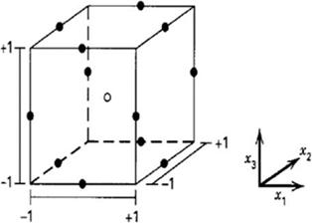

*Figure 6.5:* *Box-Behnken design*

**6.2.2 CENTRAL COMPOSITE DESIGN**

In response surface methods, the central composite design (CCD), sometimes called the Box-Wilson design, is frequently used to build second-order polynomial models for response variables. There is an alternative to carrying out a full factorial experiment with this design technique. A polynomial equation including quadratic terms needs to have at least three stages in the experimental design in order to determine its coefficients. Three different kinds of points are taken into consideration inside the CCD: factorial points, central points, and axial points. Factorial points, which are obtained from a complete or fractional factorial design with factor levels coded as -1 and +1, are equivalent to the vertices of an n-dimensional cube. The design space's centre is home to the central point, whereas the axial points are symmetrically positioned along the coordinate axes, at a distance α from the design centre.

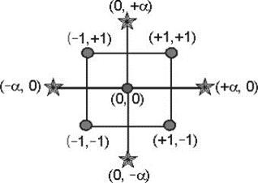

*Figure 6.6:* *Central Composite Design*

A typical central composite design (CCD) for two variables is displayed in Figure 8. Different points with diverse representations are included in the design:

* The factorial design points, indicated by the dots in the square's four corners, are represented by these points (+/-). Every corner represents a distinct set of factor levels.
* Four-star points (represented by the symbols (+/- alpha)): these represent the axial design points. Along the coordinate axes, the star points are located at alpha from the centre.
* Duplicated centre point: Usually incorporated to estimate the pure error and take into consideration experimental variability, the duplicated centre point is situated in the middle of the design.
  1. **REGRESSION EQUATIONS**

A regression equation is a mathematical model used in response surface methodology (RSM) that depicts the relationship between the response variable and the predictor factors. Based on the values of the predictor variables, it is used to approximate and forecast the behaviour of the response variable. [5]

The regression equation in RSM is usually expressed as a polynomial equation, most frequently a second-order polynomial. The formula is represented as [3]:

Y = β₀ + β₁X₁ + β₂X₂ + ... + βᵢXᵢ + βᵢⱼXᵢXⱼ + β₁₁X₁² + β₂₂X₂² + ... + βᵢᵢXᵢ² (iii)

where:

- Y represents the response variable (the outcome or output of interest).

- β₀, β₁, β₂, ..., βᵢ, βᵢⱼ, β₁₁, β₂₂, , βᵢᵢ are the regression coefficients that estimate the effect of each predictor

variable and their interactions.

- X₁, X₂, , Xᵢ represent the predictor variables (also known as the independent variables or factors).

Based on the values of the predictor variables, you may use the regression equation to estimate the value of the response variable. The strength and direction of each predictor variable's influence on the responder variable are shown by the regression coefficients. Depending on the goal of the investigation, you can find the ideal values of the predictor variables that maximise or minimise the response variable by fitting the regression equation to the experimental data.

Utilising statistical methods like least squares regression, the regression equation is created, and the coefficients are estimated to reduce the discrepancy between the values that the equation predicts and the actual values that are found in the experimental data. The link between the response variable and the predictor variables is mathematically represented by the regression equation in response surface methodology. It helps researchers to forecast, evaluate the effects of various aspects, streamline procedures, and pinpoint important relationships within the system under study. By visualising the outcomes of polynomial regression studies in a three-dimensional space, response surface analysis (RSA) is a technique that can offer a nuanced perspective of correlations between combinations of two predictor variables and an outcome variable. The method surfaced as a response to the issues surrounding the application of difference scores in discrepancy analysis.

* 1. **ANALYSIS OF VARIANCE (ANOVA)**
     1. **FINDING THE OPTIMUM RESULTS**

Finding the best outcomes in response surface methodology (RSM) entails optimising the response variable in accordance with the regression equation. An estimate of the relationship between the response variable and the predictor variables is given by the regression equation. We can use a variety of optimisation approaches to determine the best values for the predictor variables that maximise or minimise the response variable. The general procedures to determine the best outcomes are as follows:

* Establish the Goal: Choose whether you wish to reduce or increase the response variable. The process of optimisation is directed by this goal.
* Establish Constraints: List any restrictions or limitations that apply to the predictor variables. These limitations could be practical or physical limits on the variables.
* Select an Optimisation Technique: Choose an optimisation strategy that makes sense for your situation and its limitations. Response surface optimisation approaches, gradient-free methods (like genetic algorithms, particle swarm optimisation), and gradient-based methods (like gradient descent) are examples of common optimisation techniques.
* Select the Algorithm for Optimisation: Put the objective function, constraints, and any other required parameters into the optimisation algorithm's configuration along with the method of choice. Indicate which domain or range of the predictor variables the algorithm should investigate.
* Run the Optimisation Algorithm: Run the optimisation algorithm to find the predictor variable values that produce the intended response variable at their ideal values.
* Assess the Outcomes: Following the convergence or termination of the optimisation algorithm, assess the outcomes that were attained. Verify that the predictor variables' optimised values match the goals and constraints. Analyse the regression equation-based anticipated response variable that corresponds to it.
* Validate and Improve: Conduct extra tests or simulations to confirm the optimised outcomes. To increase the precision of the predictions, if needed, modify the model or add fresh data to the regression equation.
* Iterative Process: RSM optimisation is frequently a process that is iterated. To fine-tune the results and increase the precision or resilience of the optimal values, we might need to go through the preceding steps again while modifying the optimisation method, constraints, and objective.

By going through these processes, we may use the regression equation and optimisation techniques to find the response surface methodology's ideal values for the predictor variables that lead to the desired response variable.

* 1. **RESPONSE SURFACE PLOTS**

Three-dimensional graphical representations of the relationship between independent factors and the response variable are called surface plots in response surface methodology (RSM). These charts are useful tools for process parameter optimisation and for comprehending the response variable's behaviour in respect to changes in the independent variables. The following are some salient features of surface plots in RSM and their significance:

* Interactions are Visualised: The relationships between independent factors and the response variable are shown graphically via surface plots. They enable us to track the response variable's changes as the independent variables' levels fluctuate concurrently. We may see how the response variable changes over time by charting the response variable on the z-axis and two independent variables on the x- and y-axes. we can visualize how the response variable varies across the range of the independent variables.
* Determination of Ideal Conditions: Surface diagrams aid in determining the ideal circumstances for the response variable. We can identify areas where the response variable is maximised or minimised by looking at the contour lines or surface shape. This data is essential for both process optimisation and determining the best mix of independent factors to get the intended outcome.
* Comprehending Response Surface Patterns: Surface plots shed light on the trends and patterns that the response variable displays. It is possible to see if the response variable shows a straight line, a curved line, or more intricate patterns like peaks or valleys. Making better decisions is made possible by having a greater understanding of the underlying process through the recognition of these patterns.
* Visualisation of Variable Interactions: Surface plots are very helpful in illustrating how independent variables interact with one another. We can determine if the independent variables interact independently, antagonistically, or synergistically by looking at the contours or surface curvature. This knowledge is essential for determining the appropriate levels of independent variables and optimising process parameters.
* Communication and Presentation: Using surface plots to communicate and present data visually is a good idea. They offer a clear and understandable depiction of the connection between the response variable and the independent variables. Surface plots are useful for documenting and presenting research findings because they are aesthetically pleasing and may effectively communicate complex information to stakeholders.

# **CHAPTER 7: RESULTS AND DISCUSSIONS**

* 1. **AN OVERVIEW OF THE PROJECT**

This project explores the technological advancements that have revolutionized the prosthetics industry and introduces the field. Artificial devices known as prosthetics are designed to replace or enhance the functionality of missing or damaged bodily components. It is vital to emphasize the significance of prosthetic devices in helping people who have lost or malfunctioned limbs regain mobility, increase their independence, and improve their quality of life. Additionally, a variety of prosthetic devices are already available, including ones for the hands, arms, legs, feet, and facial characteristics. It's also critical to highlight the substantial improvements in design, materials, and functionality that have occurred in modern times as a result of technical developments like durable, lightweight materials, smart sensors, and complex production processes. The emphasis is on applying artificial neural networks and response surface methodology to optimize the manufacturing process of additively made PETG specimens. The study looks on the mechanical attributes and other features of composites made using 3D printing techniques. Additionally, the researchers examined the effects of various composite materials and manufacturing processes on the mechanical qualities that resulted. We address Taguchi design and ASTM standards in distinct chapters as part of our project. We presented the Taguchi Method, a potent method that combines experiment design and control parameter optimization. This approach, which makes use of orthogonal arrays (OA), allows us to perform fewer well-balanced experiments with less variation, ultimately producing optimal findings. We demonstrate how the Taguchi Method can be employed to optimize process parameters for enhancing the mechanical properties of PETG specimens.

As an internationally renowned body in charge of creating and disseminating voluntary consensus standards for a range of materials and industries, we launched ASTM standards. To guarantee product quality, safety, and performance, these standards provide specifications, test procedures, practices, guidelines, and terminologies. We highlighted the ASTM D638 Tensile Test and gave a summary of ASTM standards. Using a standard tensile test specimen, this particular standard specifies the test procedure for evaluating the tensile properties of plastics. We can learn a great deal about the mechanical behaviour of plastics under tension, including strength, elongation, modulus of elasticity, and associated properties, by performing the tensile test. Our research provides a succinct overview of ASTM standards, Taguchi design, and their importance in the prosthetics industry.

In project, we explore the application of Artificial Neural Networks (ANNs) for process parameter optimization producing PETG specimens with improved mechanical characteristics. According to our research, the ANN technique uses input and output data to train a neural network and build a link between the variables. The trained ANN is then used to predict output values for fresh input data. Additionally, we investigate how Response Surface Methodology (RSM) may be integrated to optimize process parameters and how RSM and ANN can be combined to improve prediction accuracy. We explore all facets of the used ANN approach in our analysis. This includes the training procedure, the architecture of the neural network, and the performance evaluation of the model.

* 1. **VARIATION OF EXPERIMENTAL DATA**
  2. **RESPONSE SURFACE METHODOLOGY RESULTS**
     1. **TENSILE REGRESSION MODEL**

Here is the regression equation for the ideal tension-strength, with Table 5.1 displaying the analysis of variance.

Regression Equation: Tensile Strength N/mm2 versus Layer Thickness, Printing Speed, Infill Density, Infill Pattern.

**Tensile Strength N/mm2 = 9.74 + 28.91 Layer Thickness + 0.0565 Printing Speed + 0.0336 Infill Density + 0.750 Infill Pattern**

|  |  |  |  |  |  |
| --- | --- | --- | --- | --- | --- |
| Term | Coefficient | SE Coefficient | T-Value | P-Value | VIF |
| Constant | 9.74 | 2.40 | 4.06 | 0.002 |  |
| Layer Thickness | 28.91 | 6.51 | 4.44 | 0.001 | 1.00 |
| Printing Speed | 0.0565 | 0.0326 | 1.73 | 0.111 | 1.00 |
| Infill Density | 0.0336 | 0.0217 | 1.55 | 0.150 | 1.00 |
| Infill Pattern | 0.750 | 0.326 | 2.30 | 0.042 | 1.00 |

*Table 4: Coefficients of regression model*

|  |  |  |  |  |  |
| --- | --- | --- | --- | --- | --- |
| **Source** | **DF** | **Adj SS** | **Adj MS** | **F-Value** | **P-Value** |
| Regression | 4 | 64.516 | 16.129 | 7.60 | 0.003 |
| Layer Thickness | 1 | 41.794 | 41.794 | 19.70 | 0.001 |
| Printing Speed | 1 | 6.381 | 6.381 | 3.01 | 0.111 |
| Infill Density | 1 | 5.079 | 5.079 | 2.39 | 0.150 |
| Infill Pattern | 1 | 11.263 | 11.263 | 5.31 | 0.042 |
| Error | 11 | 23.342 | 2.122 |  |  |
| Total | 15 | 87.858 |  |  |  |

*Table 4: Analysis of Variance**of regression model*

|  |  |  |  |
| --- | --- | --- | --- |
| **S** | **R-sq** | **R-sq(adj)** | **R-sq(pred)** |
| 1.45672 | 73.43% | 63.77% | 40.26% |

*Table 4: Model Summary*

The provided information shows the findings of a regression study carried out using response surface methodology. The purpose of the analysis is to comprehend how the predictor and response variables relate to one another. Examining the given information:

* Source: The sources of variation in the analysis, including the regression and error components, are listed in this column.
* DF: "Degrees of freedom" refers to the number of parameters that are calculated for each source of variation.
* Adjusted sum of squares, or AdjSS, is a statistical measure of the variation explained by each source after adjusting for degrees of freedom.
* Adjusted mean squares (Adj MS): This is the result of dividing the adjusted sum of squares by the associated degrees of freedom.
* F-Value: This is the ratio of the error's mean square to the mean square resulting from regression. It calculates how much the regression component contributes to the explanation of response variable variability.
* P-Value: Based on the null hypothesis that the relevant predictor variable has no effect on the response variable, the P-value represents the likelihood of finding an F-value that is as extreme as the one calculated. A greater degree of significance is indicated by a lower P-value.

Relying on the data above:

The statistical significance of the total regression model, comprising all predictor variables, is demonstrated by the F-value of 7.60% and the corresponding P-value of 0.003.

* The answer variable is significantly impacted by the "Infill Density" predictor variable. Its big adjusted sum of squares (41.794) and low P-value of 0.001 indicate that it accounts for a substantial amount of the response variability.
* Despite having a higher P-value of 0.150, the "Orientation" predictor variable likewise exhibits a significant impact on the response variable. Less variability is explained than with "Infill Density".
* In contrast, the response variable appears to be unaffected significantly by the "Layer Height" and "Printing Speed" predictor variables, as evidenced by their larger P-values and comparatively smaller adjusted sums of squares.

It is noteworthy that the researcher's specific context and significance criteria may have an impact on the predictor variables' significance. To comprehend the practical ramifications of the observed effects and to make wise judgments regarding the predictor variables in the response surface methodology, more analysis and interpretation are therefore necessary.

* + 1. **FLEXURAL REGRESSION MODEL**
  1. **ANOVA PLOTS.**